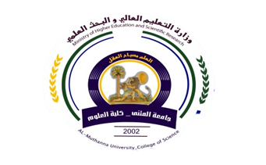
University: Al-Muthanna U.
College: Science
Department:Biology
Stage: Second
Lecturer name:Ashwaq Eyad Kadhim
Academic Status:.
Qualification: Master
Place of work: Biology

Republic of Iraq
The Ministry of Higher Education
& Scientific Research

49
Teaching plan for the semester form I
Course Instructor | Ashwaq Eyad Kadhim
E_mail | Ashwaq.alaakol@gmail.com
Title | Computer
Course Coordinator | First semester
Course Objective | Introduce students to deal with Microsoft office powerpoint 2010 and make program to interactive presentations in other areas of knowledge
Course Description | Introduction- user- preparing slides - move items in slides – save files in many Formats - the preparation of a multi-project – preparing presentations - Preparing Album
Textbook
References
Course Assessment | Term Tests | Laboratory | Quizzes | Exams | Final Exam
Course Assessment | 40% | 0% | 15% | 25% | 60%
General Notes

Republic of Iraq
The Ministry of Higher Education
& Scientific Research

University: Al-Muthanna U.
College: Science
Department:Biology
Stage: Second
Lecturer name:Ashwaq Eyad Kadhim
Academic Status:.
Qualification: Master
Place of work: Biology

49

Teaching plan for the semester form I
Week | Date | Topics Covered | Lab. Experiment Assignments | Notes
1 | 2/10 |  | Identify of the program's interface and the basic ingredients
2 | 9/10 |  | Explain and apply the commands on the File tab+ quiz
3 | 16/10 |  | Explain and apply the commands on the Home tab+ quiz
4 | 23/10 |  | Explain and apply the commands on the Insert tab+ quiz
5 | 30/10 |  | Review past lectures
6 | 6/11 |  | Exercises
7 | 13/11 |  | Explain and apply the commands on the Design tab+ quiz
8 | 20/11 |  | Explain and apply the commands on the Transitions tab + quiz
9 | 27/11 |  | Explain and apply the commands on the Animations tab + quiz
10 | 4/12 |  | A review of the lectures for the examination of the second month
11 | 11/12 |  | Explain and apply the commands on the View tab
12 | 18/12 |  | Reviewing all lectures
13 | 25/12 |  | Exercises
14
15

Instructor Signature: Head of Dept. Signature:
Ashwaq Eyad Kadhim Asst. Prof. Dr Laith Abd Alhussn

