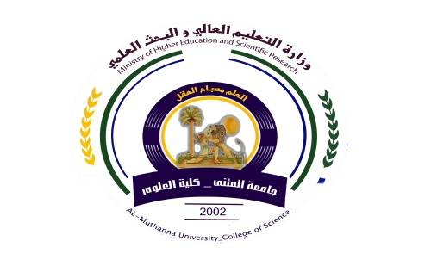
Republic of Iraq
The Ministry of Higher Education
& Scientific Research

University: ALmuthana
College: Sciences
Department:Physics
Stage: first
Lecturer name:Samar abdullah huwaidi
Academic Status: Assistant Lecturer
Qualification: Master
Place of work:Colloge of Science

Course Weekly Outline
Course Instructor | Samar abdullah huwaidi
E_mail | Samer hasen @yahoo.com
Title | Democracy (concepts and experiences)
Course Coordinator | Second semester
Course Objective | ntroduce students to the proper foundations for democracy and democracy in order to form a proper awareness of the evolving political system
Course Description | The study of the concept of democracy by knowing founded by its forms and its elements and its components with the study of the most important experiences of democracy in the world
Textbook | Book of the concepts of democracy and the experiences of Dr. Hassan Al-Zubaidi and gentle grace professor Mohammed al-Abadi
References | There is no
Course Assessment | Term Tests | Laboratory | Quizzes | Project | Final Exam
 | As (35%) | - | As (10%) | ---- | As (60%)
General Notes | There is no

Republic of Iraq
The Ministry of Higher Education
& Scientific Research

University: Al- Muthanna
College:Sciences
Department: Physics
Stage: first
Lecturer name: Samar abdullah huwaidi
Academic Status: Assistant Lecturer
Qualification: Master
Place of work: Colloge of Science

Course weekly Outline
week | Date | Topics Covered | Lab. Experiment Assignments | Notes
1 | 2017/2/22 | The concept of democracy - the definition of democracy - the intellectual underpinnings of democracy - democratic measure - Islamists and democracy - democracy and Shura - democracy and capitalism
2 | 2017/2/29 | Democratic style - election elements - Methods of election - monitoring of the elections - the House of Representatives and the responsibility - Parliament
3 | 2017/3/8 | Opposition - to identify elements of the opposition site - separation between the government and the parliament - the constitutional legitimacy
4 | 2017/3/15 | General Conditions of democracy - respect for human rights - civil rights - political rights
5 | 2017/3/22 | Political pluralism - political party - the party system - the one-party system - system parties - the multi-party system
6 | 2017/3/29 | Democratic parties - the peaceful and legitimate transfer of power - political equality - respect for the principle of majority - the existence of the rule of law
7 | 2017/4/5 | Patterns of democracy - direct democracy - semi-direct democracy - representative democracy - participatory democracy - liberal democracy - consensual democracy
8 | 2017/4/12 | Majority democracy - democracy abundance - delegated democracy - social democracy - industrial democracy - deliberative democracy
9 | 2017/4/19 | Models of democratic systems - United States - the era of independence - the US Constitution
10 | 2017/4/26 | Executive - legislative power - the judiciary - the American party system
11 | 2017/5/3 | Democracy in Iraq - the effects of the British occupation of the political process in Iraq - the party system in the monarchy
12 | 2017/5/10 | The development of parliamentary life - King - the founding of the Republic and the succession of coups
13 | 2017/5/17 | Features present democracy - the separation of powers - legislative power - the power to control the House of Representatives in the executive branch
14 | 2017/5/24 | The validity of the House of Representatives in a state of war - the executive branch - the powers of the President
15 | 2017/5/31 | The judiciary - the Supreme Judicial Council - the Federal Supreme Court - the maturation of democracy
Instructor Signature: Dean Signature:

