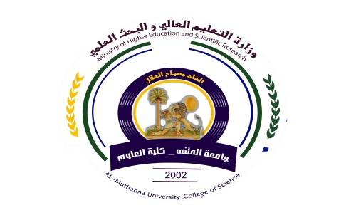
University: Al-Muthanna
College: Science
Department: Chemistry
Stage: Fourth Year
Lecturer name: Dr. Riyadh J. Nahi
Academic Status: Assistant profissor
Qualification: PhD
Place of work: Chemistry department

Republic of Iraq
The Ministry of Higher Education
& Scientific Research

Course Weekly Outline

Course Instructor | Dr. Riyadh J. Nahi
Email | riyadhnahi@yahoo.com
Title | Identification of organic compounds ( Theoretical Part)
Course Coordinator | Fourth Year Chemistry One semester
Course Objective | Giving the students skills and teach them how to identify the structure of organic compounds by spectroscopic techniques
Course Description | The course describes using UV, FT-IR, ¹HNMR, ¹³NMR, DEPT Mass spectrums to identify the structure of organic molecules.
Textbook | Spectroscopic identification of organic compounds by Robert M. Silverstein
References | Spectroscopic identification of organic compounds by Robert M. Silverstein
Course Assessment | Term Tests | Laboratory | Quizzes | Final Lab. | Final Exam
 | (20%) | (20%) | - | 30% | (30%)
General Notes

Republic of Iraq
The Ministry of Higher Education & Scientific Research

University: Al-Muthanna
College: Science
Department: Chemistry
Stage: Fourth Year
Lecturer name: Dr. Riyadh J. Nahi
Academic Status: Assistant profissor
Qualification: PhD
Place of work: Chemistry Place of Work: Chemistry department

Teaching plane form for the semester

week | Date | Topics Covered
1 | 8/10/2017 | Introductory meeting is involved a general introduction about the course.
2 | 15/10/2017 | UV and Visible Spectroscopy: Introduction to Electronic transitions Spectral Measurements, Effect of solvent on electronic transitions.
3 | 22/10/17 | UV and Visible Spectroscopy: Important terms and definitions in UV-Visible spectroscopy, Ultra Violet bands of carbonyl, unsaturated carbonyl, conjugated polyene and aromatic.
4 | 29/10/2017 | FT-Infrared spectroscopy: Introduction to IR absorption, Types of vibrations, Modes of molecular vibrations, Characteristic group vibrations of organic molecules.
5 | 5/11/2017 | FT-Infrared spectroscopy: Factors affecting on group vibrational frequencies and peak shapes.
6-7 | 12 -19/11/ 2017 | FT-Infrared spectroscopy: Interpretation of samples of IR spectrums of organic molecules.
8 | 19/11/2017 | Nuclear Magnetic Resonance (NMR) spectroscopy: Introduction to nuclear magnetic resonance NMR phenomenon, Principle of ¹H-NMR (proton spin),
9 | 26/11/2017 | Nuclear Magnetic Resonance (NMR) spectroscopy: The chemical shift and spin – spin coupling, Factors influencing chemical-shift and spin-spin coupling.
10-11 | 3-10/ 12/2017 | Nuclear Magnetic Resonance (NMR) spectroscopy: Interpretation of ¹HNMR spectrums of organic molecules.
12 | 17/12/2017 | Nuclear Magnetic Resonance (NMR) spectroscopy: Principles and introduction to DEPT and ¹³C-NMR.
13 | 24/12/2017 | Nuclear Magnetic Resonance (NMR) spectroscopy: Interpretation of ¹³CNMR and DEPT spectrums of organic compounds.
14 | 31/12/2017 | Mass spectrometry: Introduction, ion production mechanisms, rules of fragmentation, fragmentations of different functional groups, factors controlling fragmentation.
15 | 7/01/2017 | Mass spectrometry: Analysis and interpretation of Mass spectrums

Instructor Head of department Dean Signature
Dr. Riyadh J. Nahi Dr. Riyadh J. Nahi

