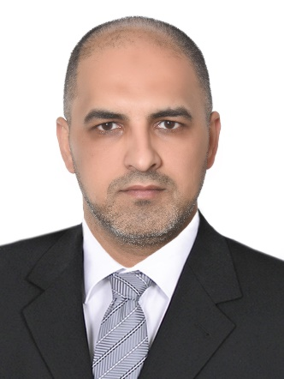

Name: Ibrahem Abdulrasol Abdulzahra
Bachelor in Veterinary Medicine/University of Baghdad 2004
Master in Anatomy and Histology/ Veterinary Medicine/University of Basra 2017
Position: Assist. Lecturer in Anatomy nd histology
E-Mail: ibrahemabdulrasol@mu.edu.iq Mobile: +964 7810665535
List publications:
- Morphological, Histological and Histochemical Study of trachea of One Hump Camel (Camelus dromedaries) In South of Iraq 2016
- Histopathological and Molecular Study of Raillietina echinobothrida of Domestic and Wild Pigeons in Al-Muthanna Province‏ 2019
- Histopathological change study of the attachment sites of adult ticks on slaughtered camels skin in Al-Muthanna Province 2020
- Genome Sequencing of a Novel Coronavirus SARS-CoV-2 Isolate from Iraq 2021

