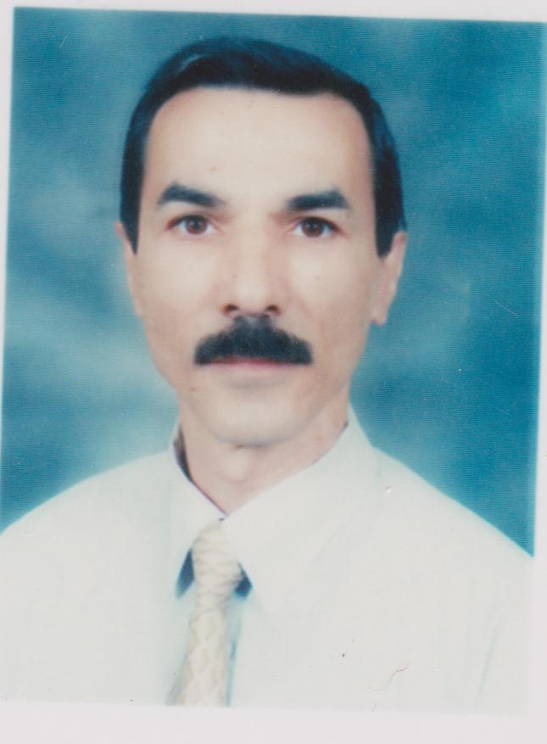ture
Full Name: Dr. Salah Naieem Abrahem
Place of Birth: Samawa, Iraq
Date of Birth: 1957
Nationality: Iraqi
Language: Arabic and English
Place of work: Physics Department, Science Faculty, Al-Muthanna University, 66001Samawa, IRAQ.
Mobile No.: +9647811980628
E-mail: zircon200036@mu.edu.iq

ACADEMIC SCIENTIFIC RANK

- Lecturer (Geophysics – Geology ) at 11-Feb.2013.
- Assistant Lecturer (Hydrology -Geology) at 11 Aug. 2003.

FELLOWSHIP

QUALIFICATION

- Ph.D. (Geophysics ), Baghdad University, Baghdad, Iraq (2013).
- M.Sc. ( Hydrology), Baghdad University, Baghdad, Iraq (1989).
- B.Sc. (Geology), Mosul University, Mosul, Iraq (1979).

Title of the PhD Thesis

The Delineation and Identification of Subsurface Archaeological Structures in Parts of Uruk Site , Al – Muthanna, Southern Iraq Using Ground Penetration Radar and 2D Electrical Imaging
Title of the MSc Thesis

Hydrology of The Khazir – Gomel River / The Greater Zab
Computer applications

- Electrical Imaging programs
- forward modeling programs( RES2DMOD &RES3DMOD software)
- inversion algorithms programs (RES2DINV& RES3DINV software)
- Georadar programs. (RadExplorer &Ground Vision software).
COURSES TAUGHT

- UNDER GRADUATE

Department | Study Stage | Subject | No.
Physics | First | Geology | 1
Chemistry | First | Geology | 2
Biology | First | Geology | 3

- PUBLICATIONS

PAPERS
1 | Abrahem ,Salah N.,AL-Gabbarri , Mugdad H. ,1995, Hydrology of The Khazir – Gomel River /The Greater Zab,I raq , Iraqi Geological Journal, Vol. 10,No.2.
2 | Abrahem ,Salah N., Thabit, Jassim M., Al – Khersan, Emad H.,2014, Comparison of 2D Resistivity Imaging Survey Using Wenner, Wenner -Schlumberger and Dipole-dipole Electrode Arrays in Uruk Archaeological Site ,Iraq ,Al- Muthanna Journal of Pure Sciences.
3 | Abrahem ,Salah N., Thabit, Jassim M., Al – Khersan, Emad H.,2015, Investigation of Subsurface Archaeological Structures Using 2D Electrical Imaging in Babylonian Houses District, Iraq, Al- Muthanna Journal of Pure Sciences.
4 | Abrahem ,Salah N., Thabit, Jassim M., Al – Khersan, Emad H.,2015, Integrated GPR and ERT as Enhanced Detection for Subsurface Historical Structures Inside Babylonian Houses Site, Uruk City, Southern Iraq , Pure and Applied Geophysics, DOI 10.1007/s00024-015-1162-2, 2015 Springer Basel.

- CONFERENCES

1 | Participation in the 1st Scientific Congress (2007) of College of Science / University of Al-Muthanna by research of the title (The Geological Effect of the Catchments Area on the River-Water Quality of Shat Al-Rumitha , Al-Muthanna Governorate).
2 | Participation in the 2nd Conference on Geological Studies in Archeology (GeoArcheo 2)(15-16|4|2015) in the College of Science / University of Baghdad by research of the title 2D Electrical Imaging of Subsurface Archaeological Structures in Babylonian Houses District, Uruk Site).

