C.V

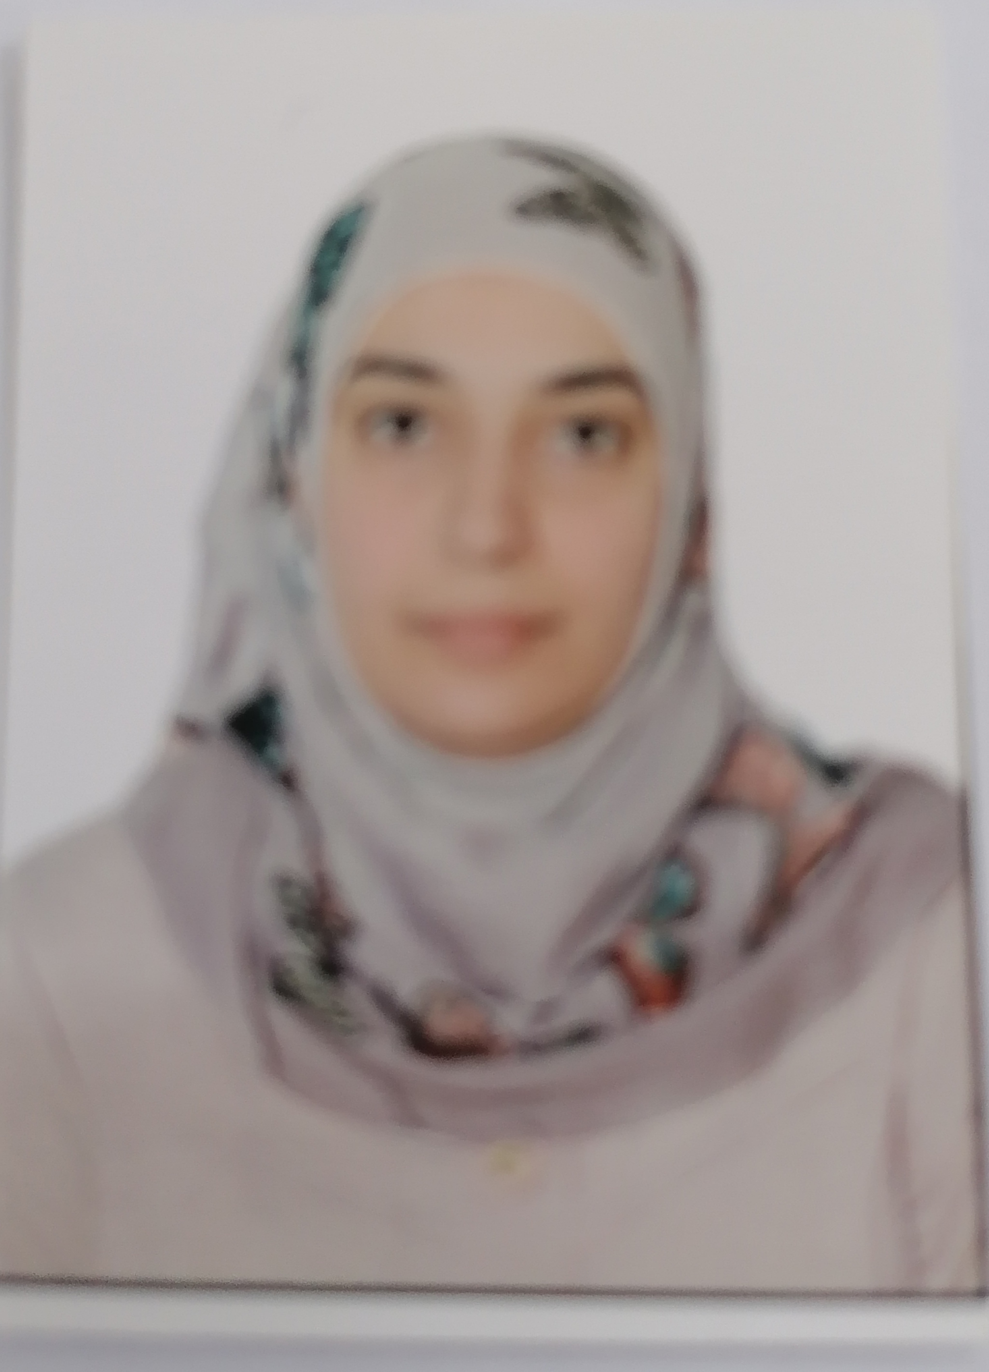

Name: DHUHA MAJEED HASAN
Date of Birth: 10 / 5 / 1982
Specialization: Chemistry
Position : University of Al-Muthanna – Iraq- Samawa
Scientific Degree: Master degree of Science
Work Address: College of Science
Work Phone:
Mobile:
Email: Dhuha.majeed@mu.edu.iq

First, Scientific Certification:

Date | College | University | Degree science
2005 | College of Science | Al-kufa University | B.Sc.
26/4/2022 | College of Science | Al-Muthanna University | M.Sc.
----- | ------ | ----- | Ph.D.
------ | ------- | ------ | Any other

From –To | Workplace | Career | No.
2008-2019 | in chemistry department / College of science / Al Muthanna University | Researcher (lab. Technical) | 1
2022-2023 | in chemistry department /  College of science / Al Muthanna University | Assist. Lecturer | 2
Second, Career:

Third, University Teaching.
From -To | The (Institute / College) | University | No.
2008-2023 | College of science | Al-Muthanna | 1
 |  |  | 2
 |  |  | 3

- Fourth, Courses Which You Teach:

Subject | Department | No.
-Organic chemistry laboratory  -Physical chemistry | Chemistry | 1
-Organic chemistry labaratory  -Organic identification | Chemistry | 2

- Fifth, Thesis which was supervised by :

Year | Department | Thesis Title | No.
2021 | chemistry | Immobilization of sodium Hydrogen sulfate onto silica and study its catalytic activity of cellulose hydrolysis | 1
 |  |  | 2

- Sixth, Conferences which you participated:
Type of Participation | Place | Year | Conferences Title | No.  ( بحث / بوستر حضور)
----------------- | --------- | -------------------------- | --------------- | 1
----------------- | --------- | ------- | ------------------- | 2

Seventh, Scientific Activities:
Outside the College | Within the College
------------------------------- | ----------------------
----------------------------- | ---------------------

- Eighth, Research Projects in The Felid of Specialization to The Environment and Society or the Development of Education:
No. | Research Title | Place of Publication | Year
1 | Fabrication of sodium hydrogen sulfate onto silica from waste for biomass energy | Chemistry africa | 2021
2 | Cellulose Hydrolysis Over Sodium Hydrogen  Sulfate | AL-Muthanna Journal | 2021

Ninth, Membership:

- Tenth, Awards and Certificates of Appreciation:

Year | Donor | Name of Awards and Certificates | No.
------ | ------- | --------------- | 1
 |  |  | 2

- Eleventh, Scientific literature:

Year of The Publication | Scientific Literature Title | No.
-------------------- | ------------------- | 1
-------------------- | ------------------ | 2

- Twelfth, languages:
- English

*Note: - Make a copy on CD.

