Curriculum Vitae

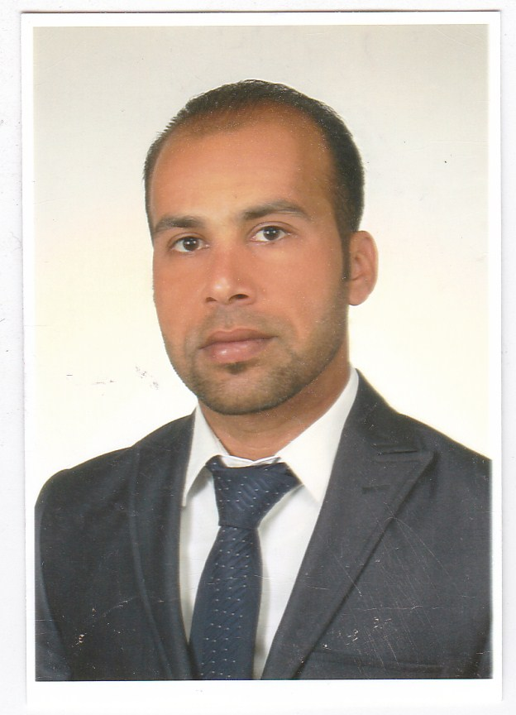
Full name : Alaa Jassim Mohammed
(PhD), Assistant professor in Physics Birthplace: Al-Muthanna – Iraq Date of Birth: 09, 30.1982
Email: alaa.mohammed@mu.edu.iq
Mob. (+964) 07831930812
Academic Education

- 2021 – 2024 PhD. in physics, University of Al-Mustansiriya, Iraq.
- 2011 – 2013 MSc. General Specialization / Physics Specialization / Laser Physics Szczecin University, Poland.
- 1998 – 2002 BSC. General Specialization / Physics, Al Muthanna University.
Work Experience

• Administrative and Legal Unit Manager at the College of Science (2014 – 2016).
• Rapporteur of the Biology Department at the College of Science (2016 – 2018).
• Registration and Student Affairs Officer (2019 – 2020).
• Rapporteur of the Chemistry Department (2020 - 2021).
• Secretary of the College of Science Council (2023 – 2024).

Conferences

- INTERNATIONAL CONFERENCE ON ENGINEERING, MEDICINE, AND APPLIED SCIENCES, http://isnra.com/icemas18conference/

1st International Conference on advanced research in pure and applied science (ICARPAS2021) , https://doi.org/10.1063/12.0010082

Publications
- Naji, W.A., Mohammed, A.J., Waheeb, M.Q. (2019) Effect of laser diode and camellia sinensis extract on some blood parameters of male laboratory rats infected with arthritis . Indian Journal of Public Health Research and Development, 2019, 10(4), pp. 1550–1555. 10.5958/0976-5506.2019.00936.7
- Rahi, S.K., Mohammed, A.J., Shakir, I.A. (2024). Optimizing laser intensity by adjusting some of parameters using pump-probe technology, Journal of Optics (India), 2024, 53(4), pp. 3988–3992.
- Alaa J. Mohammed1, Bahaa Jawad Alwan, Saif Altimime. (2023), Optical characterization of aluminum doped Cadmium selenide thin film irradiation in IR – laser. Muthanna Journal of Pure Science 2023, VOL.(10), NO.(1), 2023
Languages

- Arabic (mother tongue).
- English ( Fluent, high skills of speaking, writing, and scientific publishing).
- Other languages

Activities and Interests

Membership

Awards
- المنح ان وجدت

