Curriculum Vitae

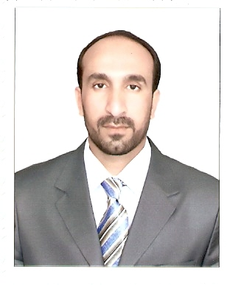
Full name: Akeel Shaker Tuhaiwer
Assistant professor in Science of Physics
Birthplace: [Al-Muthanna ] – Iraq
Date of Birth: 07, 01.1981
Email: Akeel.Almusawi@mu.edu.iq
Akeelshaker2000@gmai..com
Mob. (+964) (0) 7803196309
Academic Education

- 2011 – 2014 MSC. Physical Science – Thin Films, South Ural State University
- 2001 – 2005 BSC. Physical Science , Almuthanna University.
Work Experience

Nature of Participation | The Number | Title of Training Course
Participated | 12 | Research in international/local journals
Participated | 3 | Conferences
Participated | 15 | Seminars
Participated | 10 | Workshops
Skills and Achievements

- Skill in computer

Conferences

1 | International Conference on Materials Engineering and Science 1234567890‘’“”  IOP Conf. Series: Materials Science and Engineering 454 (2018) 012032
2 | International Conference on Materials Engineering & Science : AIP (IConMEAS 2019
3 | 2nd International Conference on Materials Engineering & Science : AIP Conference Proceedings 2213, 020010 (2020)

Publications
No. | Title of Research
1 | Determination the Optical Properties of Rhodamine Dye Doped of (PVC/PMMA) Polymers Composites Films
2 | Optical constants of cobalt chloride doped poly (vinyl alcohol) thin films
3 | Utilizing of (nTiO2) Nanoparticles in Thin Films Based on Polystyrene Blending with (DCM) Laser Dye
4 | Determination the energy gap for polyvinyl alcohol films using copper acetate as additive
5 | Effect of cobalt chloride additive on the optical properties of (PEO/PVA) composites thin films
6 | Optical and Morphological Characteristics of Nanostructured Titanium Dioxide Thin Films Prepared by DC Reactive Magnetron Sputtering Technique
7 | Optical Properties of Polyvinyl Chloride Doped with DCM dye Thin Films
8 | Optical study on deposed polystyrene doped DCM laser dye thin films at different annealing temperatures
9 | Synthesis, Characterization and Optical Properties of Polystyrene doped with DCM thin films at different temperatures
10 | Temperature effect on Electronics Properties for Alloys GaxIn1-xAs and Inp and Mole Fraction of Gallium for Alloy GaxIn1-xAs
11 | The Study of the Quantitative Properties of the Alloys Ga0.35 in 0.65 As / InP
12 | A stable dual-wavelength erbium doped fiber laser based on photonic crystal fiber and tapered optical fiber

Languages

- Arabic (mother tongue).
- English (high skills of speaking, writing, and scientific publishing).
- Russian (high skills of speaking, writing)
- Other languages

Activities and Interests
- ان وجدت

Membership

- عضوية النقابات:
- نقابة الفيزيائيين
- نقابة الاكاديميين العراقيين
Awards

- المنح ان وجدت

