Curriculum Vitae

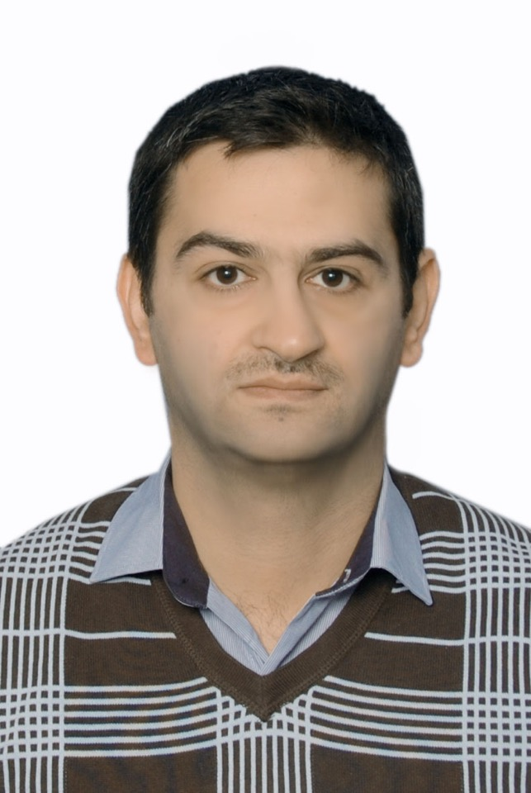o
Full name Oday Salman Mahdi
(PhD) in physics
Birthplace: [Baghdad] – Iraq
Date of Birth: 07, 16.1980
Email: oday.mahdi.sci@mu.edu.iq
Mob. (+964) (07738171540)
Academic Education

- 2020 – 2021 PhD. in physics, University of saratov, [Russia].
- 2009 – 2010 MSC in physics, Baghdad University
- 2001 – 2005 BSC in physics, mustansyria University.
- 1999 – 2000 High school, high school for boys.
Work Experience

- superconductivity
- semiconductors
Skills and Achievements

- XXXXX
- XXXXX

Conferences

- Sixth international conference (nanoparticles, nanostructured coatings and microcontainers: technology, properties, applications), 21-24 may 2015, Saratov ,Russia.

Publications
- O. S. Mahdi,V. Malyar, V. V. Galushka, A. V. Smirnov, I. V. Sinev, and S. B. Venig, Morphology and Inner Structure of Ethanol Sensitive Thin Films of Tin Oxide Operating at Near Room Temperature, ISSN 1063-7850, Technical Physics Letters, 2017, Vol. 43, No. 6, pp. 531–534. © Pleiades Publishing, Ltd., 2017.
- О.С. Махди, И.В. Маляр , А.М. Захаревич , А.В. Смирнов,И.В. Синёв, С.Б. Вениг . Фазовый состав тонких пленок оксида олова, газочувствительных при температуре, близкой к комнатной, Письма в ЖТФ, 2017, том 43, вып. 14
- Muna M. Abbas, Lamia K. Abbas, oday Salman and Milko Iliev Raman Study of Bi 2-x Cu x Pb 0.3 Sr 2 Ca 2 Cu 3 O 10+ δ Compounds , Australian Journal of Basic and Applied Sciences, 9(33) October 2015, Pages: 461-466
- Influences of Sintering Time on the T C of Bi 2-x Cu x Pb 0.3 Sr 2 Ca 2 Cu 3 O 10+ δ High Temperature Superconductors
- Effect of Sintering Temperature on Bi 2-x Cu x Pb 0.3 Sr 2 Ca 2 Cu 3 O 10+δ Superconductors
Languages

- Arabic (mother tongue).
- English (writing, and speaking).
- Other languages (rusian) ,( writing and speaking)

Activities and Interests

Membership

Awards

