Curriculum Vitae

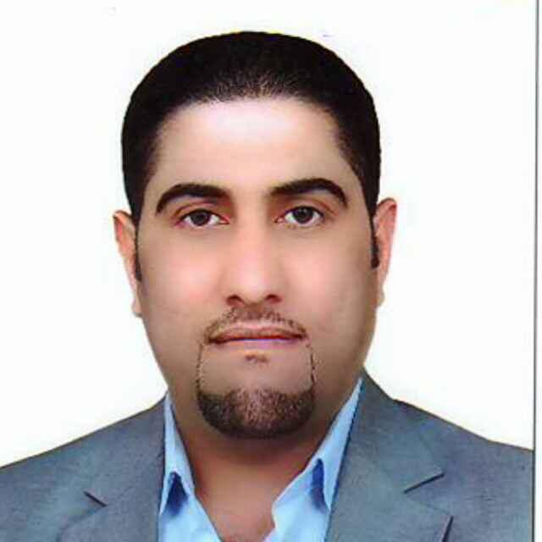
Full name: Majed Kamil Getheth
PhD. in Digital Image Processing
Birthplace: [Muthanna] – Iraq
Date of Birth: 12, 13.1980
Email: majed_kamil@mu.edu.iq
Mob. (+964) (0) 7806436086
Academic Education

- 2020 – 2024 PhD. in Digital Image Processing, University of Mustansiriyah, [Iraq].
- 2014 – 2016 MSC. Physics – Applied electronics, Osmania University, [India]
- 2001 – 2005 BSC. Physics, AL Muthanna University.
- 1997 – 2000 High school, AL Muthanna high school for boys.
ACADEMIC /TEACHING EXPERIENCE

- Computer Lab.
- Analog Electronics Lab.
- Digital Electronics Lab.
- General Physics Lab.
- General Mathematics
- Differential Equations
- General Physics.
- Biophysics.
- General Astronomy.
- Biostatistics.
- Chemical Statistics.
- General Mechanics.
- Electrical Physics.
- Spectra.
Skills and Achievements

Conferences

- The Fourth International Conference on Pure Sciences, College of Education, Al-Mustansiriya University, AIP.
- International Research Conference on Engineering and Applied Sciences 2023, College of Engineering, AL- Iraqia University, AIP
Publications

- Mohamed, A. N., Qetheth, M. K., & Odah, J. F. (2024). Utilizing of Nanometal Oxides for Treatment of Refinery Product Water: A Review. MJPS, 11(2).‏
- Qetheth, M. K., Al-Zuky, A. A., & Hamza, B. H. (2024, March). Building a multi-human bodies detection at different distances based on RCNN and faster RCNN techniques. In AIP Conference Proceedings (Vol. 3036, No. 1). AIP Publishing.
- Qetheth, M. K., Al-Zuky, A. A., & Hamza, B. H. (2023). Investigating the effect of distance on the implementation of RCNN automatic detection technique to the human body. Journal of the College of Basic Education, 29(121), 32-18.
- TUHAIWER, A. S., QETHETH, M. K., & Al Hamade, H. T. (2020). Determination the Optical Properties of Rhodamine Dye Doped of (PVC/PMMA) Polymers Composites Films. International Journal of Pharmaceutical Research (09752366), 12(2).
- QETHETH, M. K., TUHAIWER, A. S., Talib K. M. (2020). Optical constants of cobalt chloride doped poly (vinyl alcohol) thin films. Test Engineering and Management, 83,(May-June 2020), 10033-10040.
Languages
- Arabic (mother tongue).
- English (Fluent, high skills of speaking, writing, and scientific publishing).

Membership
Activities and Interests

Awards

