Curriculum Vitae

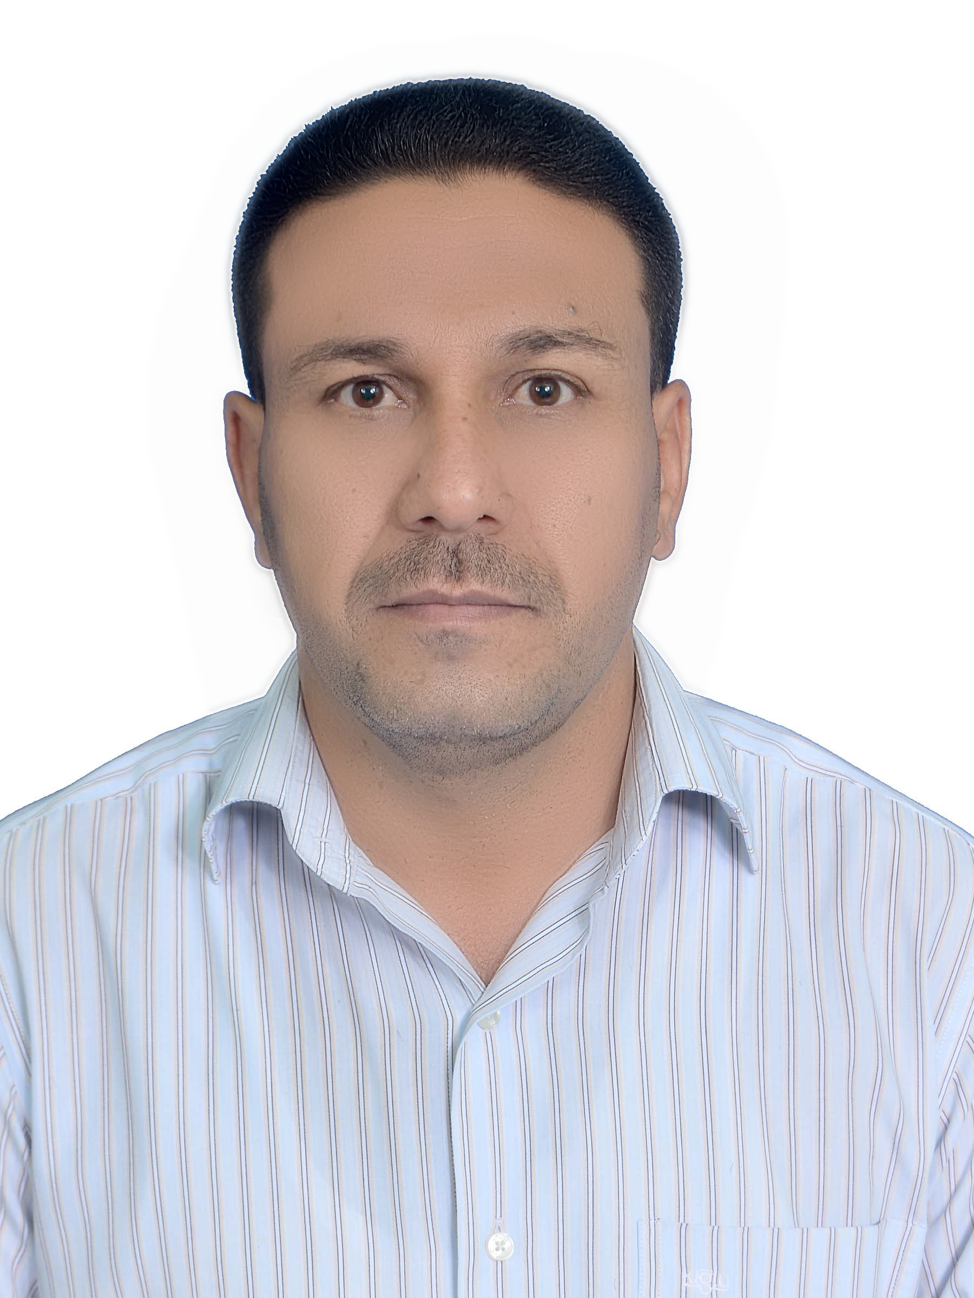oto
Full name: Hassan Tarikhum B.
Assist. prof. Dr. in Renewable energy
Birthplace: Al Muthanna – Iraq
Date of Birth: 1-1-1979
Email: hassan.tarikhum@mu.edu.iq
Mob. (+964) (0) 07839303933
Academic Education

- 2019 – 2023 PhD. in Renewable energy, University of Basrah, Iraq.
- 2010 – 2012 MSC. Solid State Physics, Istanbul University, Turkey.
- 1996 – 2000 BSC. Physics, Mosel University, Iraq.
- 1993 – 1996 High school, Al Jahidh high school for boys, Iraq.
Work Experience

Skills and Achievements

Conferences

2nd International Conference on Materials Engineering & Science (IConMEAS 2019)
Cite as: AIP Conference Proceedings 2213, 020010 (2020); https://doi.org/10.1063/5.0000114
Published Online: 25 March 2020

Publications
- B. Hassan Tarikhum, B. Ali, F. Almyahi, Role of Fullerene ICxA and Non-fullerene Y6 in P3HT-based Ternary Organic Photovoltaics, Solid State Commun. 372 (2023) 115319. https://doi.org/10.1016/j.ssc.2023.115319.
- H.B. Tarikhum, F. Almyahi, B. Ali, Optical, Structural, and Electrochemical Properties of P3HT:Y6 Photoactive Layer for Organic Photovoltaics, Karbala Int. J. Mod. Sci. 9 (2023) 618–627. https://doi.org/10.33640/2405-609X.3328.
- H.T. B, B. Ali, F. Almyahi, M.A. Mahdi, Effect of Poly (3-Hexylthiophene ): Mixed Fullerene Indene-C 60 Multi- Adducts Ratios on the Performance of Organic Solar Cells, Iran. J. Mater. Sci. Eng. 20 (2023) 1–14. https://doi.org/10.22068/ijmse.3147.
- H.T.B. Al Hamade, A.N. Sabbar, A.S. Tuhaiwer, Temperature effect on electronics properties for alloys GaxIn1-xAs and InP and mole fraction of gallium for alloy GaxIn1-xAs, AIP Conf. Proc. 2213 (2020). https://doi.org/10.1063/5.0000114.

Languages

- Arabic (mother tongue).
- English (writing, and scientific publishing).
- Turkish

Activities and Interests
Membership

Awards

- Turkey Scholarship

