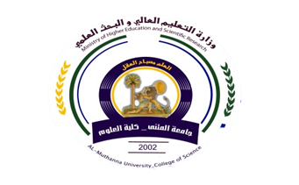
University:Al-Muthanna
Faculty :Science
Department:Biology
Stage:M.Sc. Students
Lecturer name:
Academic Status:
Qualification:
Place of work:Al-MuthannaUniversity/
Faculty ofScience.

Republic of Iraq
The Ministry of Higher Education
& Scientific Research

Teaching plan for the second semester form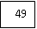
Course Instructor | Bassim Abdullah Jassim
Email | bassimabd@mu.edu.iq
Title | Prof. Dr. in Histology science
Course Coordinator | 15 weakes,2 hour per weak
Course Objective | Advance Histology
Course Description | learning the students of normal histological structures in the all body organs that composed the deferent systems.  The students able to differentiation between the normal and abnormal tissue in the body.  Preparation the tissue section during the histological techniques.
Textbook | Basic histology 8 edition
References | Biology journals, science of cell, applied of histology
Course Assessment | Term Tests | Quizzes | Project | Final Exam
Course Assessment | 20 | 5 | 5 | 70
General Notes | Type here general notes regarding the course

University:Al-Muthanna
Faculty :Science
Department: Biology
Stage: M.Sc. Students
Lecturer name:
Academic Status:
Qualification:.
Place of work:Al MuthannaUniversity/Faculty of Science

:
Place of work:

Republic of Iraq
The Ministry of Higher Education
& Scientific Research

49

Teaching plan for the second semester form
week | Date | Topics Covered | Notes
1st |  | Histological technique | no
2nd |  | Cytology and cell divisions | no
3rd |  | Epithelial tissue and glands | no
4th |  | Connective tissue and the ground substances | no
5th |  | Muscular tissue and muscle actions | no
6th |  | Nervous tissue and embryonic origin | no
7th |  | Central and peripheral nervous systems | no
8th |  | Digestive system and associated glands | no
9th |  | Cardiovascular system and Blood | no
10th |  | Lymphatic system, Lymphatic fluid | no
11th |  | Respiratory system and mechanism of respiration | no
12th |  | Urinary system and urine formation | no
13th |  | Integumentary system and hair formation | no
14th |  | Male reproductive system and spermatogenesis | no
15th |  | Female reproductive system and Oogenesis | no

Instructor Signature: Dean Signature:

