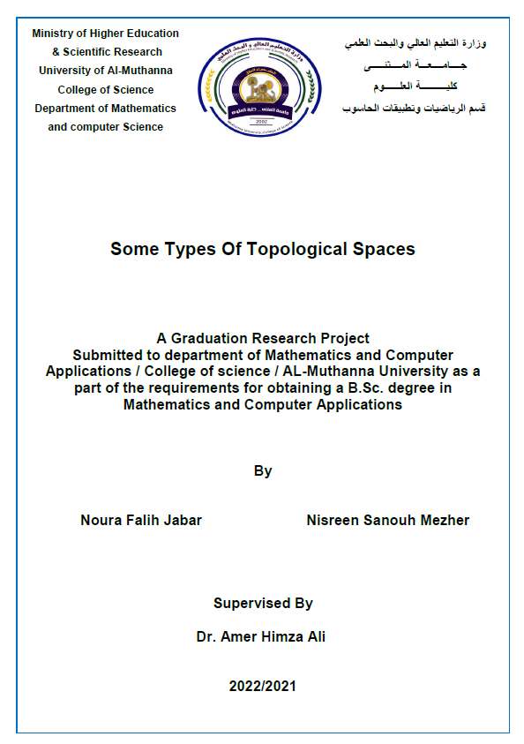
Abstract :
In this project we have studied some types of topological space
and explained the relationship between each type of them and the
topological space . we built some examples and prove some theories
which support our research ,We also mentioned the relationship between
each type and another.

