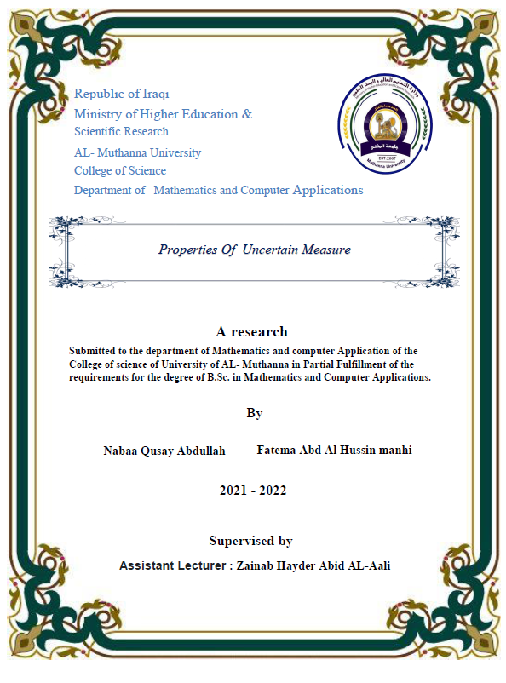
Abstract :-
Uncertain variables are measurable functions from uncertainty spaces to the set of real numbers. In this project, convergence concepts of uncertain variables sequence are presented. In addition, some relations among convergence in almost surely and uniformly almost surely of uncertain variables are also given and proven.

