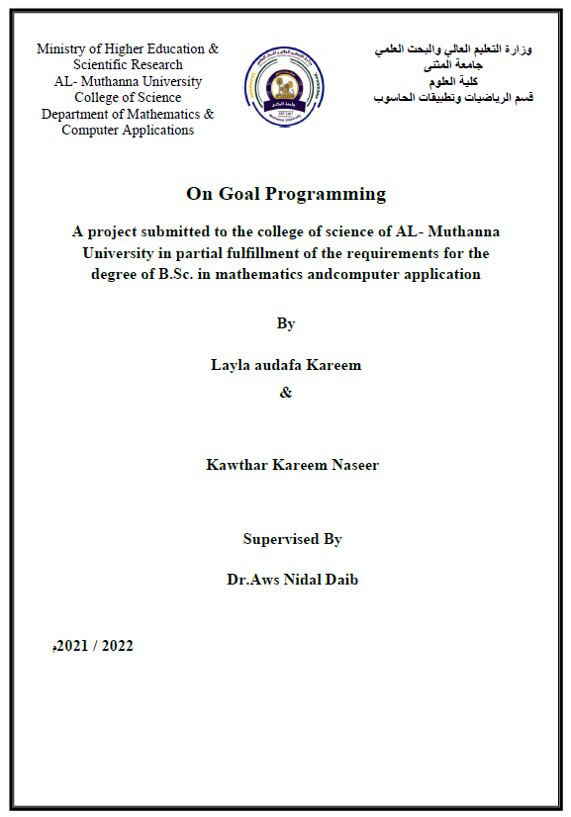
Abstract
Goal Programming (GP) is a relevant and simple technique in operations Research that helps
Decision Makers in solving problems involving conflicting and competing criteria and
objectives .and the (GP) applications to industrial and economic planning are reviewed , and it is shown how the linear programming framework can be extended to include a series of
goals ( or objectives ) a planning method is suggested in which the decision maker is presented with a list of all the possible goals from which he picks the most appropriate se

