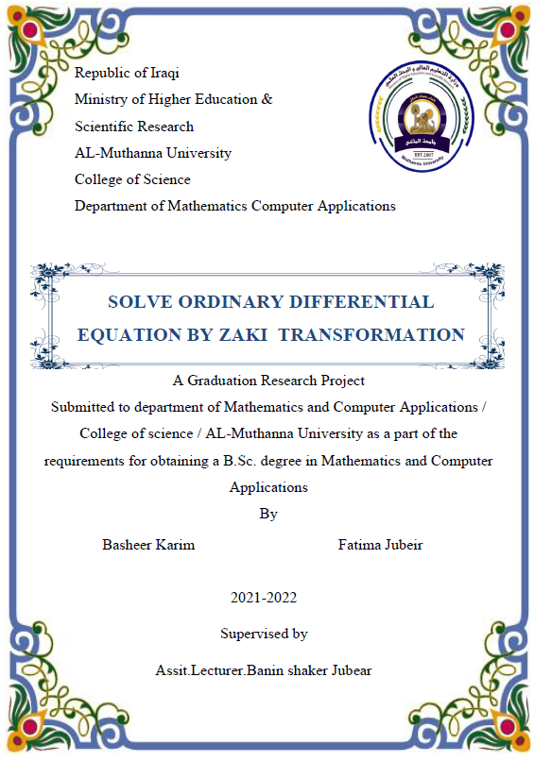ABSTRACT
Abstract
In this paper a new integral transform namely Elzaki transform was applied to solve linear ordinary differential equations.
Introduction
The differential equations represent the most important phenomena occurring in the world. This phenomenon is importance in applied mathematics, physics, and issues related to engineering. The importance of obtaining the exact solution of differential equations is still a big problem that needs new methods to discover new exact or approximate solutions. Several techniques such as A domain decomposition method [1],
Variation iteration method [2, 3], Homotopy perturbation method [4], Laplace decomposition method [5, 6, 8], Sumudu decomposition method [7], have been used Such that is the original function and to solve linear and nonlinear partial differential equations. The main aim of this paper is to solve the differential equations by using of ELzaki transform

