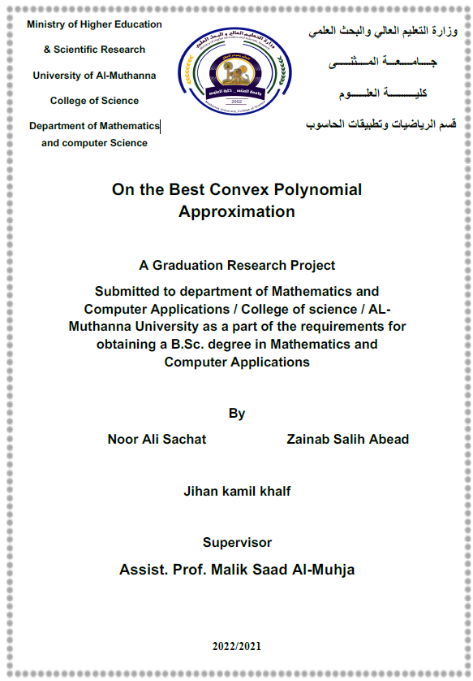

Abstract
Estimating the degree of approximation in the uniform norm, of a
convex function on a finite interval, by convex algebraic
polynomials, has received wide attention over the last twenty years.
However, while much progress has been made especially in recent
years by, among others, the authors of this article, separately and
jointly, there have been left some interesting open questions. In this
paper we give final answers to all those open problems. We are able
to say, for each 𝑟th differentiable convex function, whether or not its
degree of convex polynomial approximation in the uniform norm
may be estimated by a Jackson-type estimate involving the
weighted Ditzian–Totik 𝑘th modulus of smoothness, and how the
constants in this estimate behave. It turns out that for some
pairs (𝑘,𝑟)we have such estimate with constants depending only on
these parameters. For other pairs the estimate is valid, but only with
constants that depend on the function being approximated,
while there are pairs for which the Jackson-type estimate is, in general.

