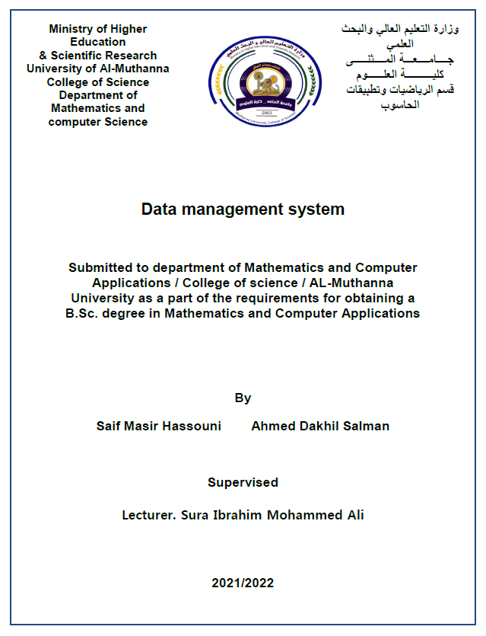
Abstract
Database Management Systems (DBMS) are software
systems used to store, retrieve, and run queries on data. A
DBMS serves as an interface between an end-user and a
database, allowing users to create, read, update, and delete
data in the database.
DBMS manage the data, the database engine, and the
database schema, allowing for data to be manipulated or
extracted by users and other programs. This helps provide
data security, data integrity, concurrency, and uniform data
administration procedures.
DBMS optimizes the organization of data by following a
database schema design technique called normalization,
which splits a large table into smaller tables when any of its
attributes have redundancy in values. DBMS offer many
benefits over traditional file systems, including flexibility and
a more complex back up system.

