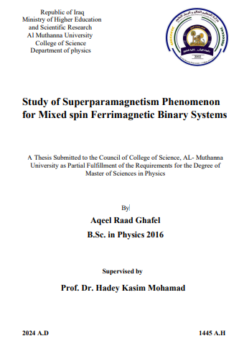

**ABSTRACT**

In this research work, it has been investigated the superparamagnetism phenomenon of ferrimagnetic mixed spins (3/2,7/2) and (2,7/2) square and triangular Blume-Capel Ising decorated systems for a series of molecular-based magnets, which is analytically dealt with by using the molecular mean-field approximation (MMFA). Besides, the magnetic properties have been investigated to clarify the physical background of the characteristic phenomena observed in the proposed ferrimagnetic mixed models. The effect of crystal field domains ( i.e., single-ion anisotropies) on the compensation phenomenon has been considered. We have shown the effect of exchange interactions on the magnetization curves and the phase transitions of these geometrical lattices. Based on the Blume-Capel Ising model, the results have been evaluated. The obtained longitudinal magnetizations were achieved by minimizing the free energy, an exciting function for the proposed systems' location, and induction of phase transitions. The magnetic crystal fields have been carefully changed to induce exciting phenomena such as superparamagnetic behaviors and the compensation temperatures of the proposed systems. Comparable studies have been done equally for decorated ferrimagnetic mixed spin square and triangular lattices. The square and triangular lattices within the effect of crystal fields and external magnetic fields on ferrimagnetic mixed spin-3/2, spin-7/2, and spins (2,7/2) decorated devices, respectively, were tested. It is worth noting that spin-3/2 ions are located as nodal, and in the surroundings of the lattice, there are four or six other spin-7/2 ions. New features have been found that the mixed spin square or triangular decorated ferrimagnets make superparamagnetism for different values of, with fixed values of DA/|J2|= 8, D.B./|J2|= -11, and J1= -0.5, J2=1, for mixed spin square and triangular lattices, respectively. The superparamagnetism phenomenon does not appear in the positive values of magnetic anisotropies. That means the proposed system maintains its phase in first-order or secondorder transition. It has been found that specific materials played an essential role in supporting the storage applications in communication technology. The heterocomplex, mainly " Cr CN CN Gd H O bpy nH O nbpy [ ( ) 4 (μ − ) 2 ( 2 ) 4 − ( )]n .4 2 .1.5 , has been synthesized successfully. It contains gadolinium Gd(III ) and chromium Cr(III ) atoms, coupled ferrimagnetically, Cr+3, and the Gd+3 moments that possess anti-parallel coupling may have been discovered.