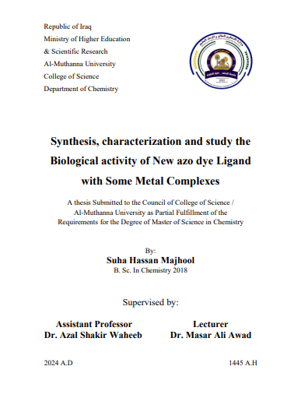

**Abstract**

The study involved the preparation and characterisation of a new hetero cyclic azo ligand 2-[2’-(5- methylthiazolyl) azo]-5-,6-dimethyl benzoimidazol derived from 2-amino-5-methyl thiazole. A series of metal complexes were prepared with the metal ions Co(III), Ni(II), Cu(II), Ag(I), and Au(III).The prepared compounds were identified by FTIR spectra, 1HNMR , 13CNMR spectra, mass spectrometry, UV-Vis spectrometry, TGA technique, FESEM ,and XRD spectroscopy as well as elemental microanalysis (C.H.N.S). The results showed the azoi ligandi 2-[2’-(5- methylthiazolyl) azo]-5-,6-dimethyl benzoimidazol behavesi as a bidentatei ligand. The molar ratio of the studied metali ions Co(III) and Cu(II) in their coordination complexes were determined (1:2) [ M:L], and the expected shape of these complexes is octahedral. On the other hand, the Ni(II), Agi(I), and Aui(III) were (1:1) [M: L] and the expected shape of these complexes were tetrahedral with ion Ag(I), and square planar with Ni(II), Au(III) ions. Finally, the new azo ligand and its metal complexes were tested in vitro for antimicrobial activity against two types of bacteria (Streptococcus, Escherichia coli) and one type of fungus (Penicillium sp). Toxicity examinations of some compounds prepared on human cells for cancer (lung, and pancreas) were studied to find out the possibility of using this type of compound as a drug by treating it with human cancer cells.