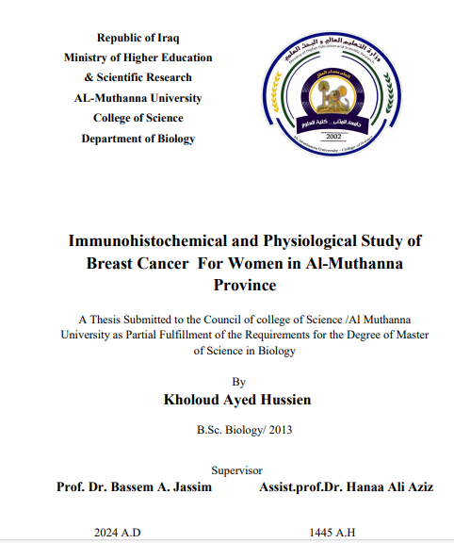

Abstract
Cancer is a highly fatal disease that affects communities all over the world, and breast cancer is the most common form of cancer among women on a global scale. Breast cancer is the second most common cause of death in Iraq, right after cardiovascular disease. This study was carried out at Al-Muthanna University in Iraq, particularly within the College of Science. The sampling phase spanned from November 2022 to May 2023. Total of sixty samples (40 patients and 20 healthy) were gathered and categorized into three distinct groups: a breast cancer patients group of 30-39 years old (12 patients and 8 healthy), a patients at 40-49' group (19 patients and 8 healthy), and a third group 50-60 years old (9 patients and 4 healthy ). The age spectrum of participants ranged from (30 to 60) years in all patient groups. The primary aim of this study to identify specific histological alterations to breast cancer patients as a comparative study, also assessing the measurement of marker expressions employed in immunohistochemistry to diagnosing breast cancer. Additionally, was to evaluate variations in hematological, histological and biochemical factors among breast cancer patients. Two categories of samples were collected for the study: blood samples and biopsy samples. The tissue specimens pass through a sequence of histological steps, encompassing the application of staining techniques such as Haematoxylene and eosin (H&E) and (PAS) Periodic AcidSchiff's. The tissue section of women breast after infection showed prominent histological changes which included, the breast parenchyma having abnormal cellular proliferation in various locations inside of the breast, also the adipose tissue has wide separation among the breast parenchyma, most adipocyte has huge in size with prominent nuclei peripherally location, all adipocytes were filled with the adipose droplets at 30-39 years. In the histological section, we find that the affected breast has blood congestion of the main blood vessels, as well as hemorrhage of blood in the areas of the breast stroma, the tissue field noted many irregular spaces filled with thick secretion and other spaces filled with blood these findings were very prominent at 40-49 years old compared with control groups. The important histological changes observed in the age group of 50-60 years included the breast parenchyma characterized by high amount of fibrosis and little adipose tissue and high aggregation of inflammatory cells, also the histopathological lesions noted in the infected breast many necrosis

