Virology: is the study of viruses and virus-like agents, including their taxonomy, disease-producing properties, cultivation and genetics.It is often considered a part of microbiology or pathology.
Virus definition
A virus is a very small, non-cellular parasite of cells.
Itʼs genome, which is composed of either DNA or RNA, is enclosed in a protein coat.
Viruses infect all cellular life forms: eukaryotes (vertebrate animals, invertebrate animals, plants, fungi) and prokaryotes (bacteria and archaea). The viruses that infect prokaryotes are often referred to as bacteriophages, or phages for short

Viruses are dependent on their hosts for most of their requirements, including
• Building-blocks such as amino acids and nucleosides.
• Protein-synthesizing machinery (ribosomes).
• Energy, in the form of adenosine triphosphate.
Some viruses are useful:
1-Phage typing of bacteria
2-Sources of enzymes
3-Pesticides
4-Anti-bacterial agents
5-Anti-cancer agents
6-Gene vectors

General properties of viruses
- They are small size (20-300 nm in diameter) retaining infectivity after passage through filters able to hold back bacteria.
- They are totally dependent upon a living cell, either eukaryotic or prokaryotic, for replication and existence. Viruses are obligate intracellular parasites.
- They possess only one species of nucleic acid, either DNA or RNA.
- They have a component -a receptor binding protein for attaching to cells.

Comparison between viruses and bacteria
No. | Properties | Viruses | Bacteria
 | Size | 20-300 nm | 1000 nm
 | Genome (type of nucleic acid) | DNA or RNA but not both | DNA and RNA
 | Cell wall | Envelope present in some viruses | Cell wall
 | Ribosomes | No ribosomes | Ribosomes
 | Multiplication by binary fission | - | +
 | Sensitivity to antibiotics | - | +
 | Growth in culture media | Growth only in living host cell | Growth in culture media

The structure of viruses

l. Viral nucleic acid:

The viral nucleic acid is located internally and can be either single- or double- stranded RNA or DNA. The nucleic acid can be either linear or circular. The DNA is always a single molecule, the RNA can exist either as a single molecule or in several pieces (segmented).
• Some RNA viruses are positive polarity and others are negativepolarity.
• Positive polarity is defined as RNA with same base sequence as the mRNA.
• Negative polarity has a base sequence that is complementary to the mRNA.

2. Capsid:

The protein shell, or coat, that encloses the nucleic acid genome and mediates attachment of the virus to specific receptors on the host cell surface. This interaction of the viral proteins with the cell receptor is the major determinant of species & organ specificity. The capsid proteins protect the genome from degradation by nucleases.

3. Capsomeres:

Morphologic units seen in electron micrscope.Each capsomere, consisting of one or several proteins.The structure composed of nucleic acid+capsid proteins is called (nucleocapsid).

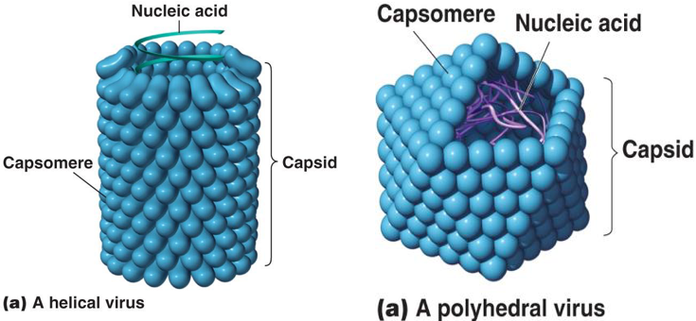

- Viral envelope :

The envelope is a lipoprotein membrane composed of lipid derived from the host cell membrane and protein that is virus- specific.
Furthermore, there are frequently glycoproteins in form of spike-like projections on the surface, which attach to host cell receptors.

Matrix protein mediates the interaction between the capsid proteins and envelope. Viruses also have internal proteins, some of which are DNA or RNA polymerases, others do not.
The presence of an envelope confers instability on the virus.
Virion NA + capsid + envelope
The whole virus partical is called virion

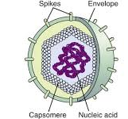

Outer viral proteins are also important antigens that induce neutralizing antibody & activate cytotoxic T cell to kill virus - infected cells.

Types of symmetry of virus particles:

1. Icosahedral symmetry
Composed of l2 vertices, has 20 faces (each an equilateral triangle) with the approximate outline of a sphere. e.g. Herpesviruses, Adenoviruses.
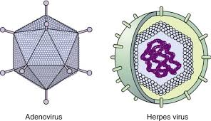

2. Helical symmetry
In which the capsomeres are arranged in a hollow coil that appears rod-shaped. The helix can be either rigid or flexible. e.g. Influenza viruses
3. Complex structures e.g. Poxviruses

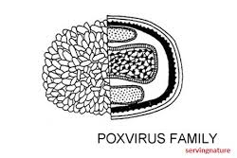

Classification of viruses

l. Virion morphology, including size, shape, type of symmetry presence or absence of envelope.
2. Virus genome properties, including type of nucleic acid (DNA or RNA), size of genome, strandedness (single double), whether linear or circular, positive or negative sense (polarity), segments (number, size).
3. Physicochemical properties of the virion, including PH stability, thermal stability, and susceptibility to physical and chemical agents, especially ether and detergents.
4. Virus protein properties, including number, size and functionalactivities of structural and non-structural proteins, amino acidsequences, and special functional activities (transcriptase, reverse transcriptase, neuraminidase, fusion activities).
5. Genome organization and replication, including gene order, strategyof replication (pattems of transcription, translation), and cellular sites (accumulation of proteins, virion assembly, virion release).
6. Antigenic properties
7. Biological properties, including natural host range, mode oftransmission, vector relationships, pathogenicity, tissue tropisms, andpathology.

Universal system of virus taxonomy:
Families — on the basis of virion morphology, genome structure andstrategies of replication.
Virus family names have the suffix — viridae.
Genera — based on physicochemical or serological differences.
Genus names carry the suffix — virus.

Reaction to physical and chemical agents:

1. Heat and cold
Viral infectivity is generally destroyed by heating at 50 to60 Cofor30 mint., hours at 20 C°, days at 4 C°. Viruses can bepreserved at -196 C° (liquid nitrogens).

2. PH`
Viruses can be preserved at physiological PH (7.3).

3. Ether susceptibility
Ether susceptibility can be used to distinguish viruses that possess an envelope from those that do not.

4. Detergents
Nonionic detergents solubilize lipid constituents of viral membranes. The viral proteins in the envelope are released. Anionic detergents also solubilize viral envelopes; in addition, they dismpt capsids into separated polypeptides.

5. Salts
Many viruses can be stabilized by salt in concentrations of 1 mol/L. e.g. MgCl2, MgSO4, and Na2SO4.

6. Radiation
Ultraviolet, X-ray, and high-energy particles inactivate viruses,

7. Formaldehyde
Destroys viral infectivity by reacting with nucleic acid.

8. Antibiotics
Antibacterial antibiotics have no effect on viruses.

Atypical virus-like agents
1-Defective viruses: are composed of viral nucleic acid and proteins. Viruses usually have a mutation or a deletion of part of their genetic material.

2-Pseudovirions: contain host cell DNA instead of viral DNA within the capsid.

3-Viroids: Consist solely of a single molecule of circular RNAwithout a protein coat or envelooe.

4-Prions: are infectious particles that are composed solely of protein. No detectable nucleic acid.
They are implicated as the cause of certain "slow" diseases called transmissible spongiform encephalopathies:
• Creutzfeldt-Jakob disease in humans.
• Scrapie in sheep
The term spongiform refers to the sponge-like appearance of the brain seen in these diseases. The holes of sponge are vacuoles resulting from dead neurons.

Prion proteins are encoded by a cellular gene. When these proteins are in normal configuration, they are non pathogenic, but when their configuration changes, they aggregate into filaments, which disturb neuronal function and results in the symptoms disease.

Prions are highly resistant to inactivation by UV light, heat; they are rermarkably resistant to formaldehyde and nucleases. They are inactivated by hypochlorite, NaOH, and autoclaving.
Prions transmitted by human growth hormone and neurosurgical instruments.
Because they are normal human proteins, they do not elicit aninflammatory response or an antibody response in humans.

Bovine spongiform encephalopathy
"Mad cow" disease. Cattle eating brains obtained from sheepinfected with scrapie prions.

