Host Immune Response

Viral Activation of Immunity
Immunity to viral infection is caused by a variety of specific and nonspecific mechanisms. The activation of different immune functions and the duration and magnitude of the immune response depend on how the virus interacts with host cells (on whether it is a cytolytic, steady-state, latent, and/or integrated infection) and on how the virus spreads (by local, primary hematogenous, secondary hematogenous, and/or nervous system spread). Therefore, viral antigens may be present in different parts of the body depending on the route of spread and phase of infection. Local infections at surfaces such as the mucosa can elicit local cell-mediated and humoral (IgA) immune responses, but not necessarily systemic immunity. The host has multiple immune defense functions that can eliminate virus and/or viral disease.
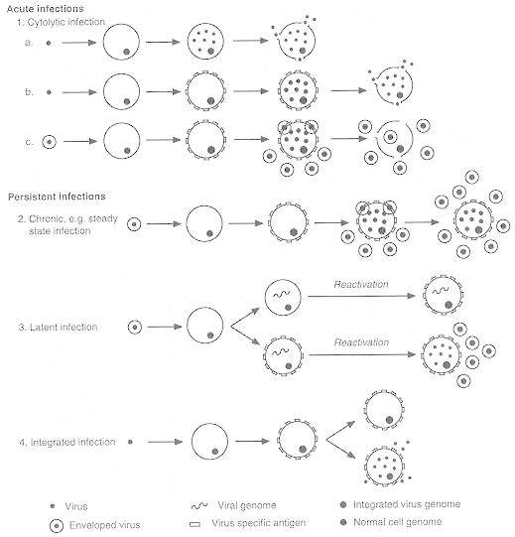

Figure 1: Virus-host cell interaction

The degree to which viral antigens are exposed to the host immune defenses is governed by the obligate intracellular replication of viruses. This exposure varies according to the virus-host cell interactions shown here; i.e., acute (cytolytic infections); persistent (steady-state infections, latent infections, and integrated infections).
Innate response against viruses
The most effective mechanisms of the innate response against viral infections are mediated by interferon and by the activation of NK cells. These mechanisms are mainly aimed against infected cells.
Interferon is a cytokine with three different types: a, b and g. The first two are mainly produced by monocytes-macrophages and to a lesser extent by fibroblasts.
However, interferon-g is produced by CD 4 and CD 8 lymphocytes and NK cells. Interferon has a strong anti-viral action and promotes different mechanisms
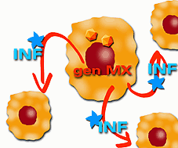
Fig.2: Activation of genes that produce anti-viral proteins

Adaptive response against viruses.
The adaptive immunity has two important cells: B and T cells (B means cells that mature in the bone marrow, while T cells develop in the thymus). B cells make antibodies, and are not as useful in defending against virus infection as T cells. T cells are highly important in the immune response to virus infection because they do a few things:
- Kills virus-infected cells
- Activate interferon that inhibits virus replication
- Activates cells that kills virus-infected cells
The major defense against virus-infected cells is the CD8+ T-cell, also called cytotoxic T cell (CTL), killing of virus-infected cells.
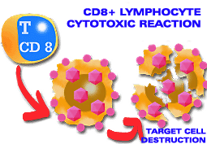
Fig.3: Cytotoxic mechanism induced by CD 8 lymphocytes

Humoral Immunity: Virus and/or virus-infected cells can stimulate B lymphocytes to produce antibody (specific for viral antigens) Antibody neutralization is most effective when virus is present in large fluid spaces (e.g., serum) or on moist surfaces (e.g., the gastrointestinal and respiratory tracts). IgG, IgM, and IgA have all been shown to exert antiviral activity. Antibody can neutralize virus by: 1) blocking virus-host cell interactions or 2) recognizing viral antigens on virus-infected cells which can lead to antibody-dependent cytotoxic cells (ADCC) or complement-mediated lysis. IgG antibodies are responsible for most antiviral activity in serum, while IgA is the most important antibody when viruses infect mucosal surfaces.
Cell-Mediated Immunity: The term cell-mediated immunity refers to (1) the recognition and/or killing of virus and virus-infected cells by leukocytes and (2) the production of different soluble factors (cytokines) by these cells when stimulated by virus or virus-infected cells. Cytotoxic T lymphocytes, natural killer (NK) cells and antiviral macrophages can recognize and kill virus-infected cells. Helper T cells can recognize virus-infected cells and produce a number of important cytokines. Cytokines produced by monocytes (monokines), T cells, and NK cells (lymphokines) play important roles in regulating immune functions and developing antiviral immune functions.

Virus-Induced Immunopathology
Immune-mediated disease may develop in certain virus infections in which viral antigens and uncontrolled immune hypersensitivity to them persist for a long period. Immune-mediated disease can be mediated by both humoral and cell-mediated immune functions. Immune-complex syndrome can be mediated by virus/virus antigen antibody complexes. T cells (cytotoxic and helper) can also mediate immunopathologic injuries via a number of mechanisms. Immunopathology can result from tissue/organ damage via cytotoxic T cells, inflammation induced via cytokines, antibody plus complement, antibody-antigen complexes and/or ADCC.

Roles of Immune Functions during Viral Infections
The early, nonspecific responses (nonspecific inhibition, natural killer cell activity, and interferon) limit virus multiplication during the acute phase of virus infections. The later specific immune (humoral and cell-mediated) responses function to help eliminate virus at the end of the acute phase, and subsequently to maintain specific resistance to reinfection.

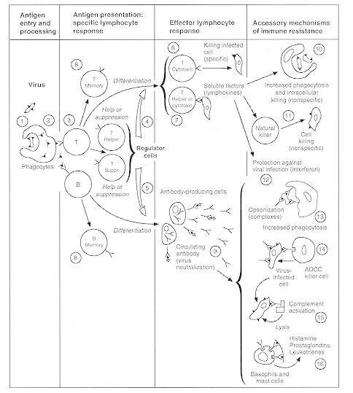

Figure 4: The immune system response to a virus
(1) Virus bearing an antigenic epitope. (2) Processing of antigen to fragments. (3) Presentation of antigen (Ag) to T cells (on the infected cell surface) and B cells (free antigenic pieces or viruses). (4 and 5) Regulator T cells help (4) or suppress (5) both B and T effector responses. (6) Antigen-specific cytotoxic (killer) T cells. (7) T cells (helper as well as cytotoxic) produce lymphokines. (8) Some lymphocytes (both T and B) activated by antigen differentiate into a long-lived pool of memory cells responsible for rapid, secondary response to the same antigen. (9) Antibody combines with antigen (neutralization, elimination). (10 and 11) Products of T cells activate macrophages for killing of ingested virus (10) and natural killer cells (11) for nonspecific cytotoxicity against virus-infected cells. (12) Interferons are produced for protection of surrounding cells against virus infection. (13) Complexing of antibody with virus (opsonization) increases the engulfment of the virus by phagocytes and can neutralize virus. (14) Binding of antibody to infected target cells activates the antibody-dependent cytotoxic cell (ADCC). (15) Complement enzymatic cascade is activated by antigen-antibody complex (in this case, the antigen is on the cell surface). (16) Antibody binds to immunoglobulin receptors on basophils and mast cells.

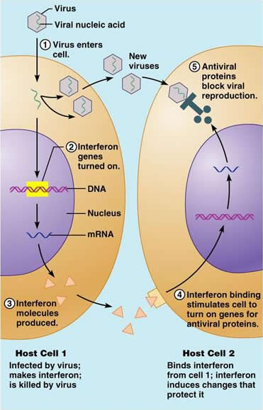
Once produced and released from virus-infected cells, IFN diffuses to uninfected neighboring cells and binds to surface receptors, inducing uninfected cells to synthesize antiviral proteins that interfere with or inhibit viral replication. (Interferons are host-cell-specific but not virus-specific).

