Urogenital system:
During embryonic development of mammals, the urogenital system develops from the intermediate mesoderm, which extends along the dorsal body wall of the embryo. During the folding of the embryo, this mesoderm is carried ventrally and then loses its connection with the somites. The longitudinal elevation of mesoderm form on each side of dorsal aorta is called the urogenital ridge, giving rise to nephrogenic ridge from which the urinary system develops
Kidney:
The mammal's kidney develops through three successive overlapping stages: the Pronephros, the Mesonephros, and the Metanephros.
Pronephros: Pronephros is the first excretory organ to form in embryo of all vertebrate species which arise from urogenital ridge in anterior region of the embryo. In humans, the pronephros, the first kidneys are formed at the beginning of the fourth week of development and represented by 7 to 10 solid cell groups in the cervical region. These groups form vestigial excretory units, nephrotomes that regress before more caudal ones are formed. By the end of the fourth week, all indications of the pronephric system have disappeared. They are rudimentary and nonfunctional consists of (7-8) primitive tubules and a pronephric duct that grows caudally and terminates in the cloacae. The tubules soon degenerate, but the pronephric duct persists as the mesonephric duct.
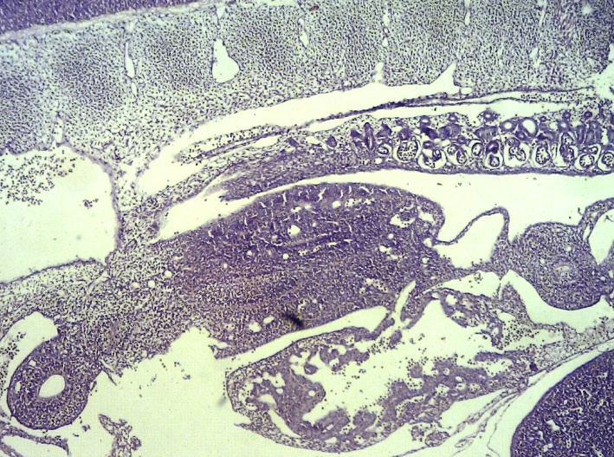

Mesonephros:
The mesonephros consists of (70-80) tubules induced to form by the mesonephric duct. One end of each tubule surrounds a vascular proliferation (glomerulus) produced by a branch of dorsal aorta. The other end of the tubule communicates with the mesonephric duct. The mesonephros eventually degenerates, but a few tubules that become incorporated within the testis and the mesonephric duct becomes epididymis or ductus deferens in the male. One end of each tubule surrounds a vascular proliferation (glomerulus) produced by a branch of dorsal aorta. The other end of the tubule communicates with the mesonephric duct. The mesonephros eventually degenerates, but a few tubules become incorporated within the testis and the mesonephric duct becomes epididymis and ductus deferens in the male. The mesonephros is the functional kidney. The mesonephric nephrons consist of a glomerulus-like body, a proximal tubule and a distal tubule, but there is a great deal of variation in the size, structure, functional maturity and developmental fate of the mesonephros between species.
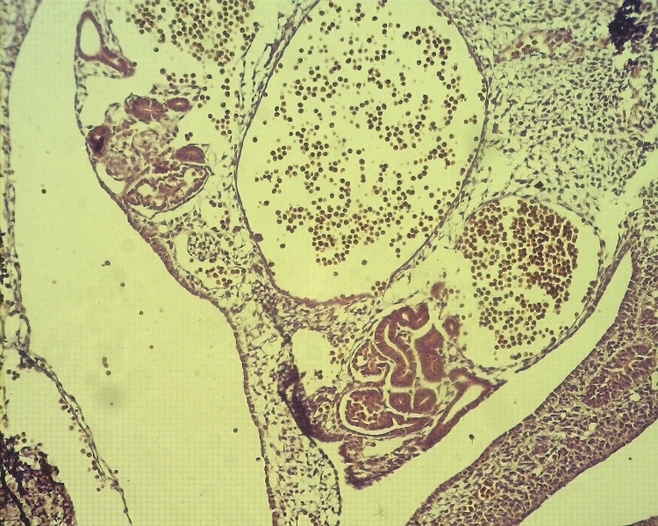

Metanephros: The mammalian kidney or the metanephros begins to develop when the ureteric bud extends into the surrounding metanephric mesenchyme. The ureteric bud epithelium invades the mesenchyme around it. The ureteric bud arises from an off shoot of the mesonephric duct and ultimately forms the ureter, renal pelvis, major and minor calyces and collecting ducts while the nephroblastic cells of the metanephric blastema, on contact with the ureteral bud, eventually develop into the glomerulus, proximal convoluted tubule, loop of Henle and distal convoluted tubule. The ureteric bud induces the metanephrogenic mesenchyme to form the nephric renal tubules; this mesenchyme reciprocally acts on the ureteric bud causing it to branch and form a tree –like system of collecting ducts, the initial tube portion of the ureteric bud is called the ureter.
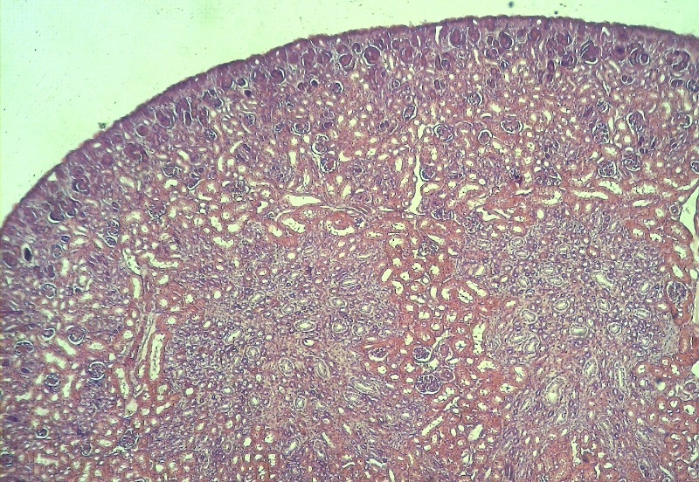

Ureter:
The development of ureter starts with the formation of the Wolffian ducts, paired epithelial tubes that extend along the anterior-posterior embryonic axis in the intermediate mesoderm. The epithelial outgrowth, the ureteric bud, appears at the level of the future hind limbs and invades a condensation of the intermediate mesoderm, the metanephric blastema and during this period the proximal part of the ureteric bud undergoes branching morphogenesis and differentiates into the collecting duct system, a process that depends on signals from surrounding metanephric mesenchymal cells, while the distal part of the ureteric bud that lies outside the kidney elongates to form the ureter tube.
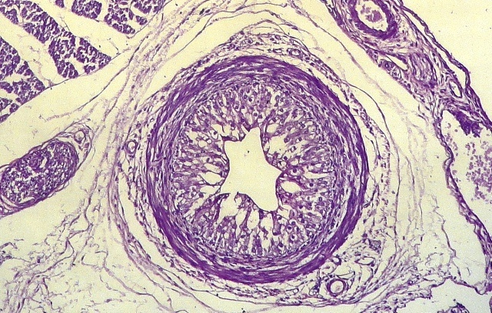
Urinary bladder:
The urinary bladder develops from expansion of the cranial end of the urogenital sinus of cloacae, including the adjacent portion of the urachus. The expansion incorporates both the mesonephric duct (future ductus deferens) and ureter into the dorsal wall of the urogenital sinus, each with a separate opening. Differential growth of the dorsal wall results in mesonephric duct and ureter openings being switched cranio-caudally, creating a trigone region that anchors the ureter to the bladder and urethra.
on days 28 of gestation, the urorectal septum extends caudally through the cloacae toward the cloacal membranes. In addition, two tissue folds advance from the lateral aspect meeting by 44 days of gestation. This separation of the cloacae into the primitive urogenital sinus and rectum is the first step in the development of the urinary bladder. By 33 days of gestation, the mesonephric duct below the ureteric bud dilates, and this "common excretory duct" is absorbed into the urogenital sinus as the precursor of the trigone. In this manner, the origin of the ureteric bud enters the bladder directly by days 37 to become the ureteric orifice. The urogenital membrane ruptures on day 48th of gestation, hence providing a connection between the emerging bladder and the outside of the body
