Medical Embryology
Dr. Bassim Abdullah jassim
College of science
Forth stage

NEURULATION
Once induction has occurred, the elongated, slipper-shaped neural plate gradually expands toward the primitive streak (Fig. 5.2, B and C ). By the end of the third week, the lateral edges of the neural plate become more elevated to form neural folds, and the depressed mid region forms the neural groove (Figs. 5.2, 5.3, A and B, and 5.4). Gradually, the neural folds approach each other in the midline, where they fuse (Fig. 5.3C ). Fusion begins in the cervical region (fifth somite) and proceeds cranially and caudally (Figs. 5.5 and 5.6). As a result, the neural tube is formed. Until fusion is complete, the cephalic and caudal ends of the neural tube communicate with the amniotic cavity by way of the cranial and caudal neuropores, respectively (Figs. 5.5, 5.6A, and 5.7). Closure of the cranial neuropore occurs at approximately day 25 (18- to 20-somite stage), whereas the posterior neuropore closes at day 27 (25-somite stage). Neurulation is then complete, and the central nervous system is represented by a closed tubular structure with a narrow caudal portion, the spinal cord, and a much broader cephalic portion characterized by a number of dilations, the brain vesicles.
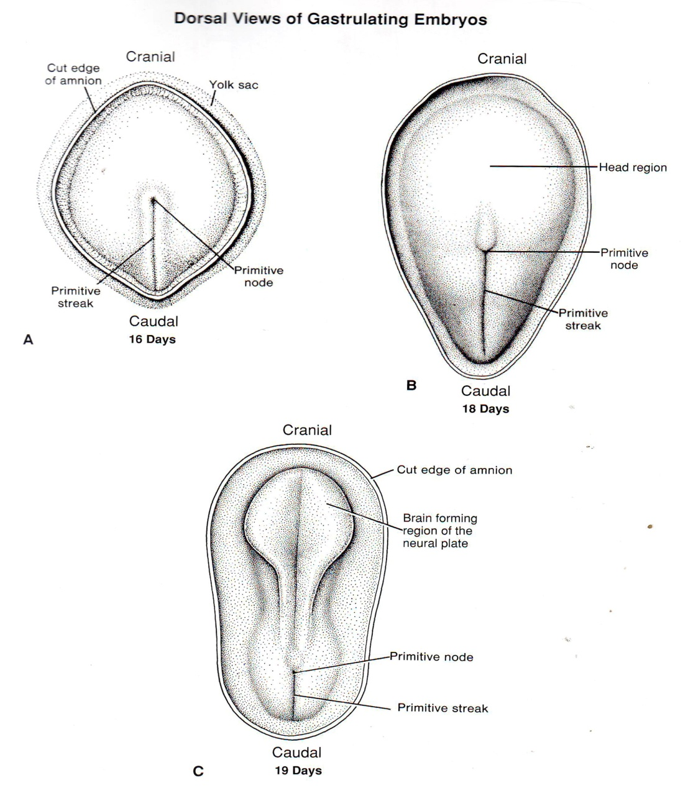

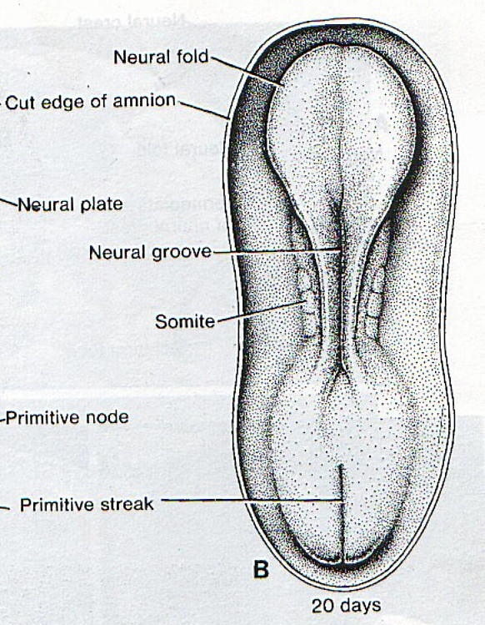

Figure 5.1 and 5.2
As the neural folds elevate and fuse, cells at the lateral border or crest of the neuroectoderm begin to dissociate from their neighbors. This cell population, the neural crest (Figs. 5.3), will undergo an epithelial-to-mesenchymal transition as it leaves the neuroectoderm by activemigration and displacement to enter the underlying mesoderm. (Mesoderm refers to cells derived from the epiblast and extraembryonic tissues. Mesenchyme refers to loosely organized embryonic connective tissue regardless of origin.) Crest cells from the trunk region leave the neural folds after closure of the neural tube and migrate along one of two pathways:
1) a dorsal pathway through the dermis, where they will enter the ectoderm through holes in the basal lamina to form melanocytes in the skin and hair follicles; and
2) a ventral pathway through the anterior half of each somite to become sensory ganglia, sympathetic and enteric neurons, Schwann cells, and cells of the adrenal medulla (Fig. 5.3). Neural crest cells also form and migrate from cranial neural folds, leaving the neural tube before closure in this region. These cells contribute to the craniofacial skeleton as well as neurons for cranial ganglia, glial cells, melanocytes, and other cell types.

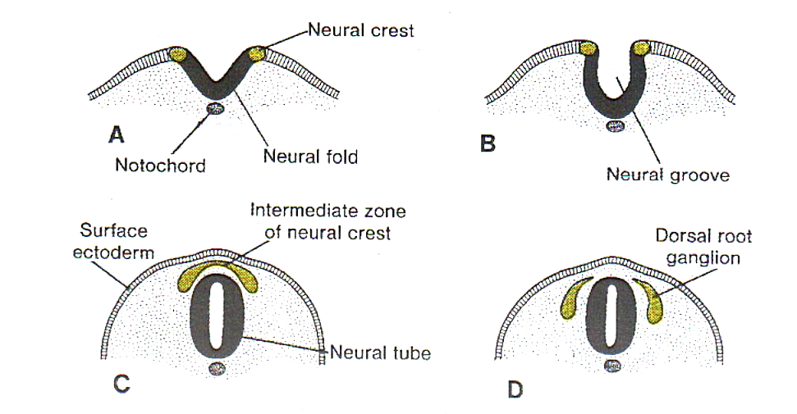

Figure 5.3
By the time the neural tube is closed, two bilateral ectodermal thickenings, the otic placodes and the lens placodes, become visible in the cephalic region of the embryo (Fig. 5.8B). During further development, the otic placodes invaginate and form the otic vesicles, which will develop into structures needed for hearing and maintenance of equilibrium. At approximately the same time, the lens placodes appear. These placodes also invaginate and, during the fifth week, form the lenses of the eyes.
In general terms, the ectodermal germ layer gives rise to organs and structures that maintain contact with the outside world: (a) the central nervous system; (b) the peripheral nervous system; (c) the sensory epithelium of the ear, nose, and eye; and (d) the epidermis, including the hair and nails. In addition, it gives rise to subcutaneous glands, the mammary glands, the pituitary gland, and enamel of the teeth.

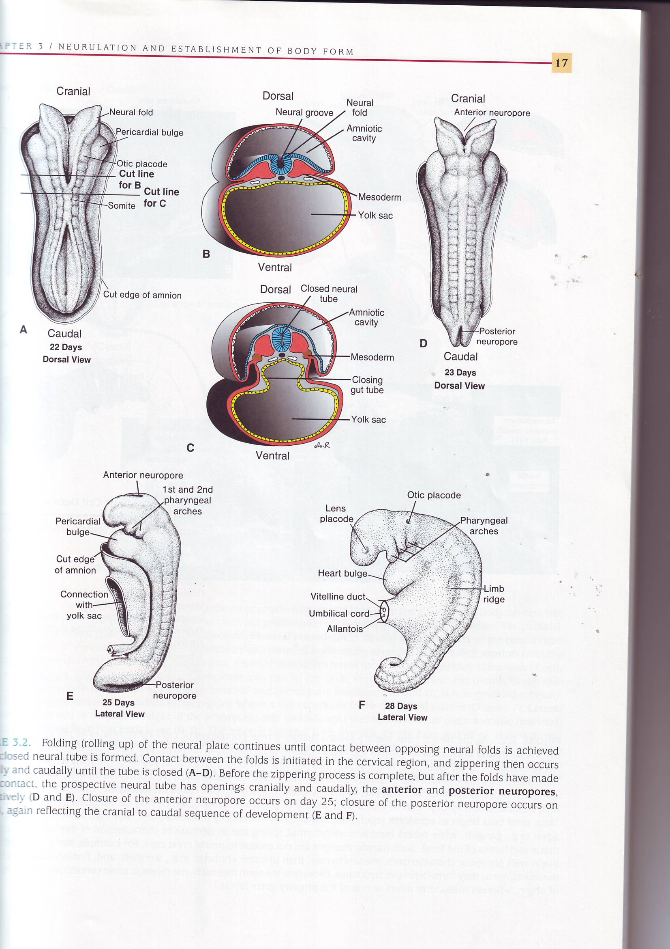

Figure 5.5

Figure 5.8
- Derivatives of the Mesodermal Germ Layer
By approximately the 17th day, however, cells close to the midline proliferate and form a thickened plate of tissue known as paraxial mesoderm (Fig. 5.9B). More laterally, the mesoderm layer remains thin and is known as the lateral plate. With the appearance and coalescence of intercellular cavities in the lateral plate, this tissue is divided into two layers (Fig. 5.9, B and C):
(a) a layer continuous with mesoderm covering the amnion, known as the somatic or parietal mesoderm layer; and
(b) a layer continuous with mesoderm covering the yolk sac, known as the splanchnic or visceral mesoderm layer (Figs. 5.9, C and D, and 5.10). Together, these layers line a newly formed cavity, the intraembryonic cavity, which is continuous with the extraembryonic cavity on each side of the embryo. Intermediate mesoderm connects paraxial and lateral plate mesoderm (Figs. 5.9, B and D, and 5.10).

Figure 5-9, 5-10

