Medical Embryology
second lecture
By
Dr. Bassim Abdullah jassim
College of science
forth stage

The embryonic life during the first week:
At puberty, the female begins to undergo regular monthly cycles. These sexual cycles are controlled by the hypothalamus. Gonadotropin-releasing hormone (GnRH) produced by the hypothalamus acts on cells of the anterior pituitary gland, which in turn secrete gonadotropins. These hormones, follicle-stimulating hormone (FSH) and luteinizing hormone (LH) stimulate and control cyclic changes in the ovary.
At the beginning of each ovarian cycle, 15 to 20 primary (preantral) stage follicles are stimulated to grow under the influence of FSH. Under normal conditions, only one of these follicles reaches full maturity, and only one oocyte is discharged; the others degenerate and become atretic. In the next cycle, another group of primary follicles is recruited, and again, only one follicle reaches maturity. Consequently, most follicles degenerate without ever reaching full maturity.
.
- OVULATION
In the days immediately preceding ovulation, under the influence of FSH and LH, the secondary follicle grows rapidly to a diameter of 25 mm. Coincident with final development of the secondary follicle, there is an abrupt increase in LH that causes the primary oocyte to complete meiosis I and the follicle to enter the preovulatory stage.
Meiosis II is also initiated, but the oocyte is arrested in metaphase approximately 3 hours before ovulation. In the meantime, the surface of the ovary begins to bulge locally, and at the apex, an avascular spot, the stigma, appears. The high concentration of LH increases collagenase activity, resulting in digestion of collagen fibers surrounding the follicle. Prostaglandin levels also increase in response to the LH surge and cause local muscular contractions in the ovarian wall. Those contractions extrude the oocyte, which together with its surrounding granulosa cells from the region of the cumulus oophorus, breaks free (ovulation) and floats out of the ovary (Figs. 2.2 and 2.3). Some of the cumulus oophorus cells then rearrange themselves around the zona pellucida to form the corona radiata (Figs. 2.4–2.6).
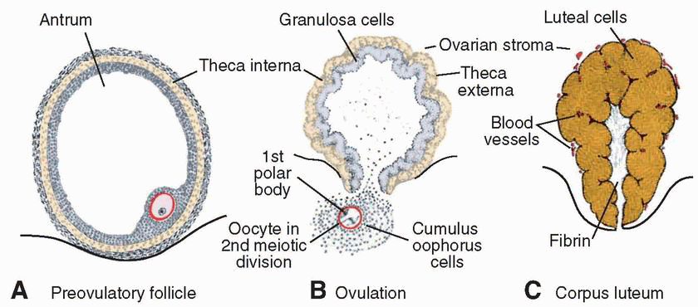

CORPUS LUTEUM
After ovulation, granulosa cells remaining in the wall of the ruptured follicle, together with cells from the theca interna, are vascularized by surrounding vessels. Under the influence of LH, these cells develop a yellowish pigment and change into lutean cells, which form the corpus luteum and secrete the hormone progesterone (Fig. 2.2C). Progesterone, together with estrogenic hormones, causes the uterine mucosa to enter the progestational or secretory stage in preparation for implantation of the embryo.
-OOCYTE TRANSPORT
Shortly before ovulation, fimbriae of the oviduct begin to sweep over the surface of the ovary, and the tube itself begins to contract rhythmically. It is thought that the oocyte surrounded by some granulosa cells (Figs. 2.3 and 2.4) is carried into the tube by these sweeping movements of the fimbriae and by motion of cilia on the epithelial lining. Once in the tube, cumulus cells withdraw their cytoplasmic processes from the zona pellucida and lose contact with the oocyte.
Once the oocyte is in the uterine tube, it is propelled by cilia with the rate of transport regulated by the endocrine status during and after ovulation. In humans, the fertilized oocyte reaches the uterine lumen in approximately 3 to 4 days.
Fertilization
Fertilization, the process by which male and female gametes fuse, occurs in the ampullary region of the uterine tube. This is the widest part of the tube and is close to the ovary (Fig. 2.4).
Only 1% of sperm deposited in the vagina enter the cervix, where they may survive for many hours. Movement of sperm from the cervix to the oviduct is accomplished primarily by their own propulsion, although they may be assisted by movements of fluids created by uterine cilia. The trip from cervix to oviduct requires a minimum of 2 to 7 hours, and after reaching the isthmus, sperm become less motile and cease their migration. At ovulation, sperm again become motile, perhaps because of chemoattractants produced by cumulus cells surrounding the egg, and swim to the ampulla where fertilization usually occurs. Spermatozoa are not able to fertilize the oocyte immediately upon arrival in the female genital tract but must undergo (a) capacitation and (b) the acrosome reaction to acquire this capability.

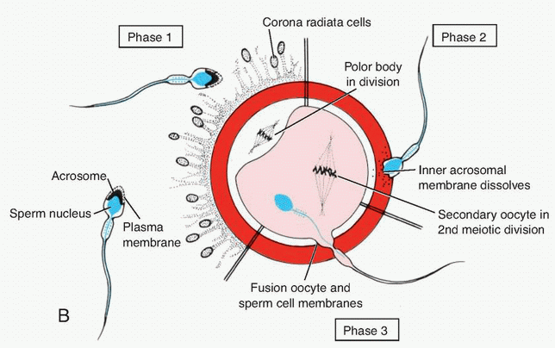

PHASE 1: PENETRATION OF THE CORONA RADIATA
Of the 200 to 300 million spermatozoa deposited in the female genital tract, only 300 to 500 reach the site of fertilization. Only one of these fertilizes the egg. It is thought that the others aid the fertilizing sperm in penetrating the barriers protecting the female gamete. Capacitated sperm pass freely through corona cells (Fig. 2.5).

PHASE 2: PENETRATION OF THE ZONA PELLUCIDA
The zona is a glycoprotein shell surrounding the egg that facilitates and maintains sperm binding and induces the acrosome reaction. Both binding and the acrosome reaction are mediated by the ligand ZP3, a zona protein. Release of acrosomal enzymes (acrosin) allows sperm to penetrate the zona, thereby coming in contact with the plasma membrane of the oocyte (Fig. 2.5). Permeability of the zona pellucida changes when the head of the sperm comes in contact with the oocyte surface. This contact results in release of lysosomal enzymes from cortical granules lining the plasma membrane of the oocyte. In turn, these enzymes alter properties of the zona pellucida (zona reaction) to prevent sperm penetration and inactivate species-specific receptor sites for spermatozoa on the zona surface.

PHASE 3: FUSION OF THE OOCYTE AND SPERM CELL MEMBRANES
The initial adhesion of sperm to the oocyte is mediated by specific receptors. After adhesion, the plasma membranes of the sperm and egg fuse (Fig. 2.5). In the human, both the head and tail of the spermatozoon enter the cytoplasm of the oocyte, but the plasma membrane is left behind on the oocyte surface. As soon as the spermatozoon has entered the oocyte, the egg responds in three ways:

- Cortical and zona reactions. As a result of the release of cortical oocyte granules, which contain lysosomal enzymes, (a) the oocyte membrane becomes impenetrable to other spermatozoa, and (b) the zona pellucid alters its structure and composition to prevent sperm binding and penetration. These reactions prevent polyspermy (penetration of more than one spermatozoon into the oocyte).

- Resumption of the second meiotic division. The oocyte finishes its second meiotic division immediately after entry of the spermatozoon. One of the daughter cells, which receive hardly any cytoplasm, is known as the second polar body; the other daughter cell is the definitive oocyte. Its chromosomes (22+X) arrange themselves in a vesicular nucleus known as the female pronucleus (Figs. 2.6 and 2.7).
- Metabolic activation of the egg. The activating factor is probably carried by the spermatozoon.

The spermatozoon, meanwhile, moves forward until it lies close to the female pronucleus. Its nucleus becomes swollen and forms the male pronucleus (Fig. 2.6); the tail detaches and degenerates. Morphologically, the male and female pronuclei are indistinguishable, and eventually, they come into close contact and lose their nuclear envelopes (Fig. 2.7A). During growth of male and female pronuclei (both haploid), each pronucleus must replicate its DNA. Immediately after DNA synthesis, chromosomes organize on the spindle in preparation for a normal mitotic division. The 23 maternal and 23 paternal (double) chromosomes split longitudinally at the centromere, and sister chromatids move to opposite poles, providing each cell of the zygote with the normal diploid number of chromosomes and DNA (Fig. 2.6, D and E ). As sister chromatids move to opposite poles, a deep furrow appears on the surface of the cell, gradually dividing the cytoplasm into two parts (Figs. 2.6F).

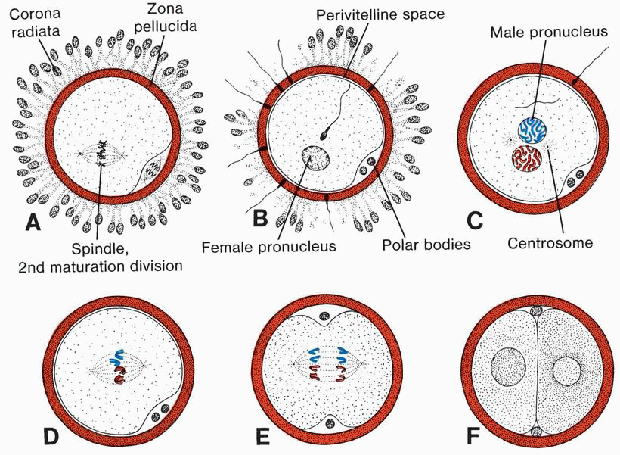

- Cleavage
Once the zygote has reached the two-cell stage, it undergoes a series of mitotic divisions, increasing the numbers of cells. These cells, which become smaller with each cleavage division, are known as blastomeres (Fig. 2.8). Until the eight-cell stage, they form a loosely arranged clump. However, after the third cleavage, blastomeres maximize their contact with each other, forming a compact ball of cells held together by tight junctions.
This process, compaction, segregates inner cells, which communicate extensively by gap junctions, from outer cells. Approximately 3 days after fertilization, cells of the compacted embryo divide again to form a 16-cell morula. Inner cells of the morula constitute the inner cell mass, and surrounding cells compose the outer cell mass. The inner cell mass gives rise to tissues of the embryo proper, and the outer cell mass forms the trophoblast, which later contributes to the placenta.
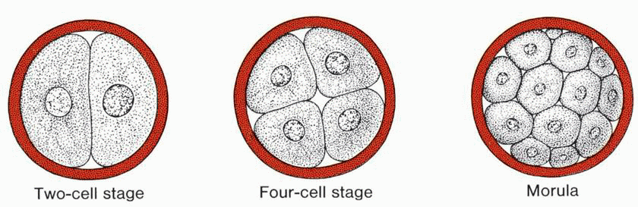

Figure 2.8
- Blastocyst Formation

About the time the morula enters the uterine cavity, fluid begins to penetrate through the zona pellucida into the intercellular spaces of the inner cell mass. Gradually the intercellular spaces become confluent, and finally a single cavity, the blastocele, forms (Fig. 2.10, A and B). At this time, the embryo is a blastocyst. Cells of the inner cell mass, now called the embryoblast, are at one pole, and those of the outer cell mass, or trophoblast, flatten and form the epithelial wall of the blastocyst (Fig. 2.10, A and B). The zona pellucid has disappeared, allowing implantation to begin.
In the human, trophoblastic cells over the embryoblast pole begin to penetrate between the epithelial cells of the uterine mucosa about the sixth day (Fig. 2.10C).
By the end of the first week of development, the human zygote has passed through the morula and blastocyst stages and has begun implantation in the uterine mucosa.
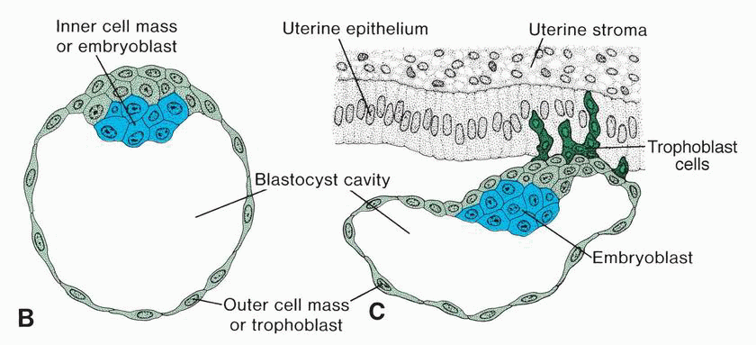

- Gastrulation: Formation of Embryonic Mesoderm and Endoderm
The most characteristic event occurring during the third week of gestation is gastrulation, the process that establishes all three germ layers (ectoderm, mesoderm, and endoderm) in the embryo. Gastrulation begins with formation of the primitive streak on the surface of the epiblast (Figs. 4.1). Initially, the streak is vaguely defined, but in a 15- to 16-day embryo, it is clearly visible as a narrow groove with slightly bulging regions on either side (Fig. 4.2). Cells of the epiblast migrate toward the primitive streak (Fig. 4.3). This inward movement is known as invagination. Once the cells have invaginated, some displace the hypoblast, creating the embryonic endoderm, and others come to lie between the epiblast and newly created endoderm to form mesoderm. Cells remaining in the epiblast then form ectoderm. Thus, the epiblast, through the process of gastrulation, is the source of all of the germ layers (Fig. 4.3B), and cells in these layers will give rise to all of the tissues and organs in the embryo.
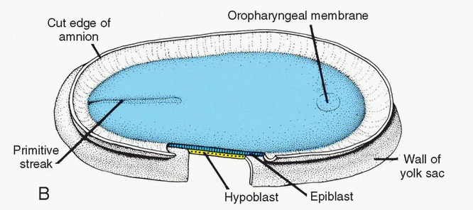

In the cephalic direction, they pass on each side of the prechordal plate. The prechordal plate itself forms between the tip of the notochord and the buccopharyngeal membrane and is derived from some of the first cells that migrate through the node in a cephalic direction.
Figure 5.2 A. Dorsal side of the germ disc from a 16-day embryo indicating the movement of surface epiblast cells (solid black lines) through the primitive streak and node and the subsequent migration of cells between the hypoblast and epiblast (broken lines). B. Cross section through the cranial region of the streak at 15 days showing invagination of epiblast cells. The first cells to move inward displace the hypoblast to create the definitive endoderm. Once definitive endoderm is established, inwardly moving epiblast forms mesoderm.
- Formation of the Notochord (please see the figures and the images in the book)
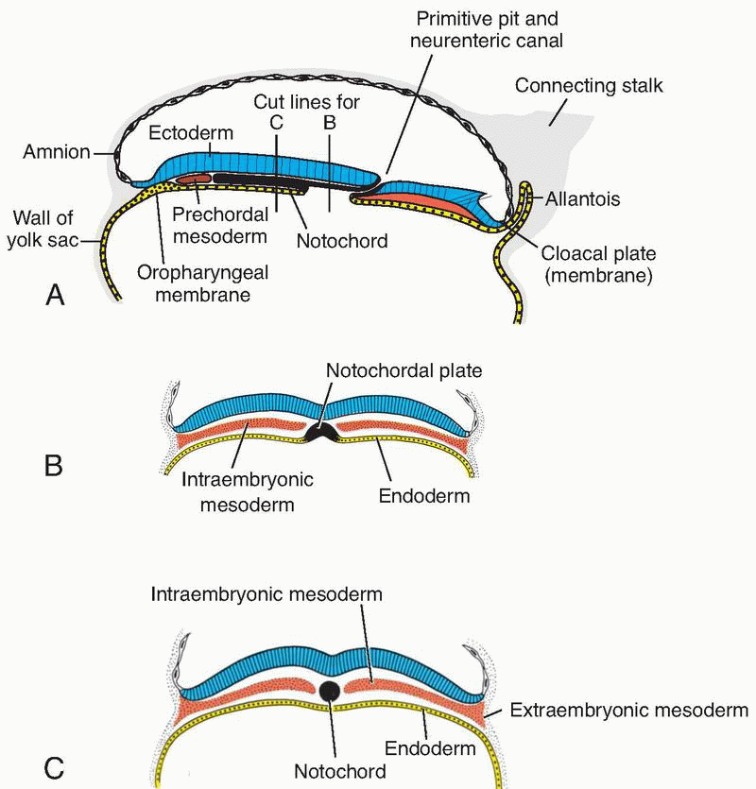
Prenotochordal cells invaginating in the primitive pit move forward cephalad until they reach the prechordal plate (Fig. 4.4). These prenotochordal cells become intercalated in the hypoblast so that, for a short time, the midline of the embryo consists of two cell layers that form the notochordal plate (Fig. 4.4, B and C ). As the hypoblast is replaced by endoderm cells moving in at the streak, cells of the notochordal plate proliferate and detach from the endoderm. Because elongation of the notochord is a dynamic process, the cranial end forms first, and caudal regions are added as the primitive streak assumes a more caudal position. The notochord and prenotochordal cells extend cranially to the prechordal plate (an area just caudal to the buccopharyngeal membrane) and caudally to the primitive pit. At the point where the pit forms an indentation in the epiblast, the neurenteric canal temporarily connects the amniotic and yolk sac cavities (Fig. 4.4A).

- Uterus at Time of Implantation
The wall of the uterus consists of three layers: (a) endometrium or mucosa lining the inside wall; (b) myometrium, a thick layer of smooth muscle; and (c) perimetrium, the peritoneal covering lining the outside wall (Fig. 2.11). From puberty (11–13 years) until menopause (45–50 years), the endometrium undergoes changes in a cycle of approximately 28 days under hormonal control by the ovary. During this menstrual cycle, the uterine endometrium passes through three stages, the follicular or proliferative phase, the secretory or progestational phase, and the menstrual phase (Figs. 2.1The proliferative phase begins at the end of the menstrual phase, is under the influence of estrogen, and parallels growth of the ovarian follicles. The secretory phase begins approximately 2 to 3 days after ovulation in response to progesterone produced by the corpus luteum. If fertilization does not occur, shedding of the endometrium (compact and spongy layers) marks the beginning of the menstrual phase. If fertilization does occur, the endometrium assists in implantation and contributes to formation of the placenta. At the time of implantation, the mucosa of the uterus is in the secretory phase (Figs. 2.11 and 2.12), during which time uterine glands and arteries become coiled and the tissue becomes succulent. As a result, three distinct layers can be recognized in the endometrium: a superficial compact layer, an intermediate spongy layer, and a thin basal layer (Fig. 2.12). Normally, the human blastocyst implants in the endometrium along the anterior or posterior wall of the body of the uterus, where it becomes embedded between the openings of the glands (Fig. 2.12).
If the oocyte is not fertilized, venules and sinusoidal spaces gradually become packed with blood cells, and an extensive diapedesis of blood into the tissue is seen. When the menstrual phase begins, blood escapes from superficial arteries, and small pieces of stroma and glands break away. During the following 3 or 4 days, the compact and spongy layers are expelled from the uterus, and the basal layer is the only part of the endometrium that is retained (Fig. 2.13). This layer, which is supplied by its own arteries, the basal arteries, functions as the regenerative layer in the rebuilding of glands and arteries in the proliferative phase.

