Virology: the science which deals with study of viruses as causative agents of very important diseases that occurs in human, animals, plants and other living organisms (insects, bacteria,…).

Virus: is infectious particle containing one type of nucleic acid and surrounded by protein coat.
The viral particle has ability to replicate only inside living host cell, and cause infectious diseases.
The term virus, which come from the Latin word for poison.
Because the viruses pass through bacterial filters, therefore the viruses were known as (filterable viruses).

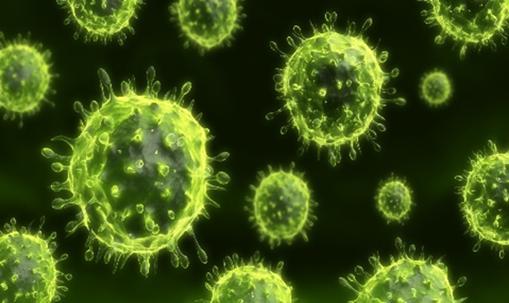

No. | Property | Viruses | Bacteria
1 | Size | 20-300 nm | 1000 nm
2 | Genome  (type of nucleic acid) | DNA or RNA but  not both | DNA and RNA
3 | Cell wall | Envelope present  in some viruses | Cell wall
4 | Ribosomes | No ribosomes | Ribosomes
5 | Multiplication by binary fission | _ | +
6 | Sensitivity to antibiotics | _ | +
7 | Growth in culture media | Grow only in  living host cell | Grow in culture  media
Comparison between virus and bacteria

General characters of viruses:
1. Virus particles are very small in size; they are between 20-400 nm (nanometer)
in diameter. 1 nm = 1/1000 µm, 1 µm=1/1000 mm.
2. They are totally dependent upon a living cell, either
eukaryotic or prokaryotic, for replication and existence.
Viruses are obligate intracellular parasites
3. Multiply inside the cells by replicating their genomes which either DNA or RNA, but not both.
4. The virus dose not contain any organelles (ribosomes, t RNA, metabolic enzymes, etc), but they depend on infected cells to provide all their needed organelles.
5. Virus does not affect with antibiotics.
6. Most viruses sensitive to interferon.
Interferons (IFNs) are a group of proteins made and released by host cells in response to the presence of several pathogens, such as viruses, bacteria, parasites, and also tumor cells
7. Viruses can not grow on artificial media, but only in living cells (specific host, Lab. Animals, chicken embryonated eggs & tissue culture).
8. Some viruses cause latent infection.
9. Viruses can not be seen by ordinary microscope, but only by Electron microscope (EM)

Viruses are not plants, animals, or bacteria, but they are the quintessential parasites of the living kingdoms.
Although they may seem like living organisms because of their reproductive abilities, viruses are not living organisms in the strict sense of the Word
Without a host cell, viruses cannot carry out their life-sustaining functions or reproduce.
They cannot synthesize proteins, because they lack ribosomes and must use the ribosomes of their host cells to translate viral messenger RNA into viral proteins.
Viruses cannot generate or store energy in the form of adenosine triphosphate (ATP), but have to derive their energy, and all other metabolic functions, from the host cell.
They also parasitize the cell for basic building materials, such as amino acids, nucleotides, and lipids (fats).
Although viruses have been speculated as being a form of protolife, their inability to survive without living organisms makes it highly unlikely that they preceded cellular life during the Earth's early evolution.
Some scientists speculate that viruses started as rogue segments of genetic code that adapted to a parasitic existence.

All viruses contain nucleic acid, either DNA or RNA (but not both), and a protein coat, which encases the nucleic acid.
Some viruses are also enclosed by an envelope of fat and protein molecules.
In its infective form, outside the cell, a virus particle is called a virion. Each virion contains at least one unique protein synthesized by specific genes in its nucleic acid.
Viroids (meaning "viruslike") are disease-causing organisms that contain only nucleic acid and have no structural proteins.
Other viruslike particles called prions are composed primarily of a protein integrated with a small nucleic acid molecule.

Viruses are generally classified by the organisms they infect, animals, plants, or bacteria.
Since viruses cannot penetrate plant cell walls, virtually all plant viruses are transmitted by insects or other organisms that feed on plants.
Certain bacterial viruses, such as the T4 bacteriophage, have evolved an process of infection. The virus has a "tail" which it attaches to the bacterium surface by means of proteinaceous "pins." The tail contracts and the tail plug penetrates the cell wall and underlying membrane, injecting the viral nucleic acids into the cell.

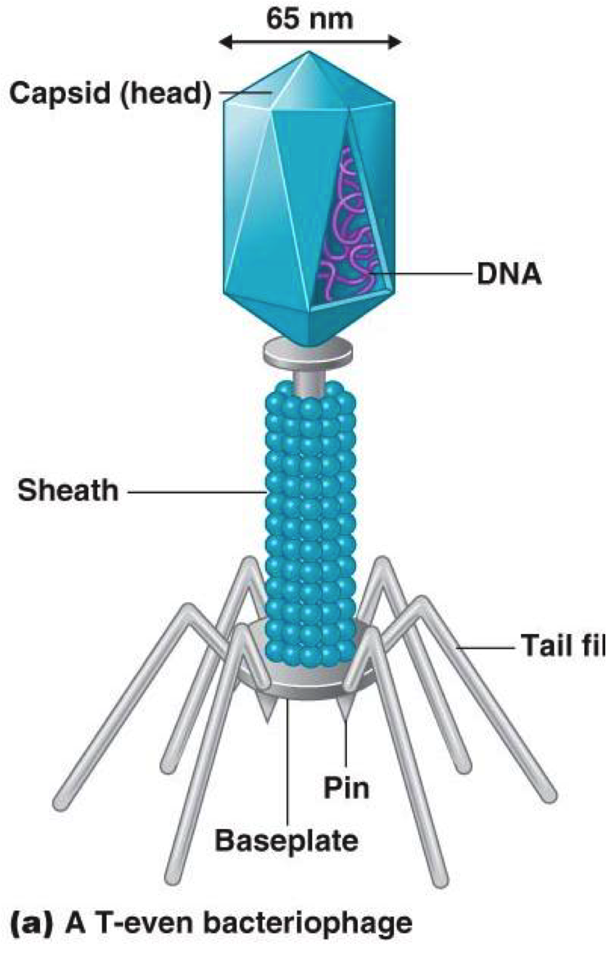
Viruses are further classified into families and genera based on three structural considerations:
1) the type and size of their nucleic acid,
2) the size and shape of the capsid
3) whether they have a lipid envelope surrounding the nucleocapsid (the capsid enclosed nucleic acid)

The structure of viruses:

1- Capsid
The capsid is the protein shell that encloses the nucleic acid; with its enclosed nucleic acid, it is called the nucleocapsid.
This shell is composed of protein organized in subunits known as capsomers. They are closely associated with the nucleic acid and reflect its configuration, either a rod-shaped helix or a polygon-shaped sphere. The capsid has three functions:
1) it protects the nucleic acid from digestion by enzymes,
2) contains special sites on its surface that allow the virion to attach to a host cell,
3) provides proteins that enable the virion to penetrate the host cell membrane and, in some cases, to inject the infectious nucleic acid into the cell's cytoplasm.
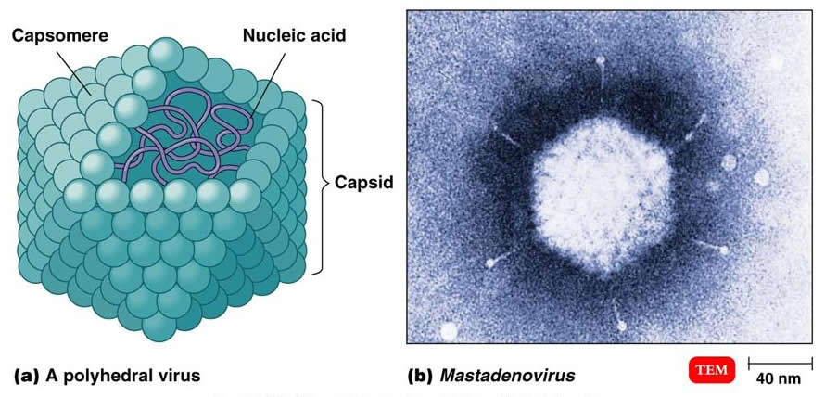

2-Envelope
Many types of virus have a glycoprotein envelope surrounding the nucleocapsid.
The envelope is composed of two lipid layers interspersed with protein molecules (lipoprotein bilayer) and may contain material from the membrane of a host cell as well as that of viral origin.
The virus obtains the lipid molecules from the cell membrane during the viral budding process.
the virus replaces the proteins in the cell membrane with its own proteins, creating a hybrid structure of cell-derived lipids and virus-derived proteins.
Many viruses also develop spikes made of glycoprotein on their envelopes that help them to attach to specific cell surfaces.
Matrix protein: mediates the interaction between the capsid proteins and envelope

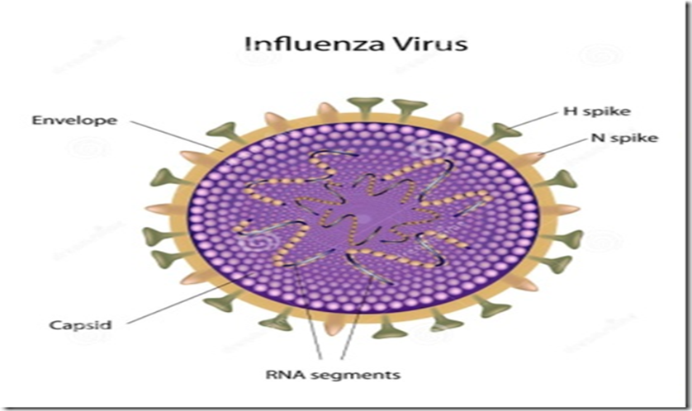
3-Nucleic Acid
the nucleic acid of each virus encodes the genetic information for the synthesis of all proteins.
While the double-stranded DNA is responsible for this in prokaryotic and eukaryotic cells, only a few groups of viruses use DNA.
Most viruses maintain all their genetic information with the single-stranded RNA.
Viral nucleic acid can be either single stranded (ss) or double stranded (ds) , linear or circular , segmented or non-segmented genome
All DNA viruses have dsDNA (except parvoviruses have ssDNA), while Most RNA viruses possess ssRNA (except reoviruses are dsRNA).
Nucleic acid of most DNA viruses and most RNA viruses is linear, but in some DNA viruses and RNA viruses is circular .
DNA genome always a single molecule(non-segmented), whereas RNA genome can exist either single or multiple molecules (segmented).
There are two types of RNA-based viruses. In most, the genomic RNA is termed Positive polarity is defined as an RNA with same base sequence as the mRNA for direct synthesis (translation) of viral protein.
A few, have negative strands of RNA. In these cases, the virion has an enzyme, called RNA-dependent RNA polymerase (transcriptase), which must first catalyze the production of complementary messenger RNA from the virion genomic RNA before viral protein synthesis can occur.

