Muscle contractions can be described based on two variables: force and length. Force itself can be differentiated as either tension or load. Muscle tension is the force exerted by the muscle on an object whereas a load is the force exerted by an object on the muscle.^{[1]} When muscle tension changes without any corresponding changes in muscle length, the muscle contraction is described as isometric. If the muscle length changes while muscle tension remains the same, then the muscle contraction is isotonic. In an isotonic contraction, the muscle length can either shorten to produce a concentric contraction or lengthen to produce an eccentric contraction. Furthermore, if the muscle length shortens, the contraction is concentric. But if the muscle length lengthens, then the contraction is eccentric. In natural movements that underlie locomotor activity, muscle contractions are multifaceted as they are able to produce changes in length and tension in a time-varying manner. Therefore, neither length nor tension is likely to remain constant when the muscle is active during locomotor activity.

Isometric contraction
An isometric contraction of a muscle generates tension without changing length. An example can be found when the muscles of the hand and forearm grip an object; the joints of the hand do not move, but muscles generate sufficient force to prevent the object from being dropped.

Isotonic contraction:
In isotonic contraction, the tension in the muscle remains constant despite a change in muscle length. This occurs when a muscle's force of contraction matches the total load on the muscle.

Concentric contraction:
In concentric contraction, muscle tension is sufficient to overcome the load, and the muscle shortens as it contracts This occurs when the force generated by the muscle exceeds the load opposing its contraction.
During a concentric contraction, a muscle is stimulated to contract according to the sliding filament theory. This occurs throughout the length of the muscle, generating a force at the origin and insertion, causing the muscle to shorten and changing the angle of the joint. In relation to the elbow, a concentric contraction of the biceps would cause the arm to bend at the elbow as the hand moved from the leg to the shoulder .

Eccentric contraction:
In eccentric contraction, the tension generated is insufficient to overcome the external load on the muscle and the muscle fibers lengthen as they contract.] Rather than working to pull a joint in the direction of the muscle contraction, the muscle acts to decelerate the joint at the end of a movement or otherwise control the repositioning of a load. This can occur involuntarily (e.g., when attempting to move a weight too heavy for the muscle to lift) or voluntarily (e.g., when the muscle is 'smoothing out' a movement).
Though the muscle is doing a negative amount of mechanical work, (work is being done on the muscle), chemical energy (in fat, glucose or ATP) is nevertheless consumed, although less than would be consumed during a concentric contraction of the same force. For example, one expends more energy going up a flight of stairs than going down the same flight.

Eccentric contractions in movement[edit]
Eccentric contractions normally occur as a braking force in opposition to a concentric contraction to protect joints from damage. During virtually any routine movement, eccentric contractions assist in keeping motions smooth, but can also slow rapid movements such as a punch or throw. Part of training for rapid movements such as pitching during baseball involves reducing eccentric braking allowing a greater power to be developed throughout the movement.

Skeletal muscle:
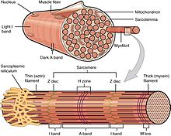
Organization of skeletal muscle
Excluding reflexes, all skeletal muscles contractions occur as a result of conscious effort originating in the brain. The brain sends electrochemical signals through the nervous system to the motor neuron that innervates several muscle fibers.^{[16]} In the case of some reflexes, the signal to contract can originate in the spinal cord through a feedback loop with the grey matter. Other actions such as locomotion, breathing, and chewing have a reflex aspect to them: the contractions can be initiated both consciously or unconsciously.

Neuromuscular junction:
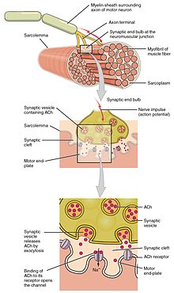
Structure of neuromuscular junction.
A neuromuscular junction is a chemical synapse formed by the contact between a motor neuron and a muscle fiber. It is the site in which a motor neuron transmits a signal to a muscle fiber to initiate muscle contraction. The sequence of events that results in the depolarization of the muscle fiber at the neuromuscular junction begins when an action potential is initiated in the cell body of a motor neuron, which is then propagated by saltatory conduction along its axon toward the neuromuscular junction. Once it reaches the terminal bouton, the action potential causes a Ca2+
ion influx into the terminal by way of the voltage-gated calcium channels. The Ca2+influx causes synaptic vesicles containing the neurotransmitter acetylcholine to fuse with the plasma membrane, releasing acetylcholine into the synaptic cleft between the motor neuron terminal and the neuromuscular junction of the
skeletal muscle fiber. Acetylcholine diffuses across the synapse and binds to and activates nicotinic acetylcholine receptors on the neuromuscular junction. Activation of the nicotinic receptor opens its intrinsic sodium/potassium channel, causing sodium to rush in and potassium to trickle out. As a result, the sarcolemma reverses polarity and its voltage quickly jumps from the resting membrane potential of -90mV to as high as +75mV as sodium enters. The membrane potential then becomes hyperpolarized when potassium exits and is then adjusted back to the resting membrane potential. This rapid fluctuation is called the end-plate potential The voltage-gated ion channels of the sarcolemma next to the end plate open in response to the end plate potential. These voltage-gated channels are sodium and potassium specific and only allow one through. This wave of ion movements creates the action potential that spreads from the motor end plate in all directions. If action potentials stop arriving, then acetylcholine ceases to be released from the terminal bouton. The remaining acetylcholine in the synaptic cleft is either degraded by active acetylcholine esterase or reabsorbed by the synaptic knob and none is left to replace the degraded acetylcholine.

Smooth muscle:
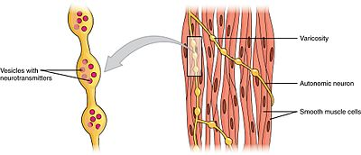
Swellings called varicosities belonging to an autonomic neuron innervate the smooth muscle cells.

Mechanisms of smooth muscle contraction:
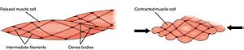
Smooth muscle contractions
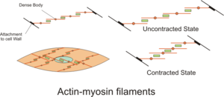
The contractile activity of smooth muscle cells is influenced by multiple inputs such as spontaneous electrical activity, neural and hormonal inputs, local changes in chemical composition, and stretch. This is in contrast to the contractile activity of skeletal muscle cells, which relies on a single neural input. Some types of smooth muscle cells are able to generate their own action potentials spontaneously, which usually occur following a pacemaker potential or a slow wave potential. These action potentials are generated by the influx of extracellular Ca2+
, and not Na+. Like skeletal muscles, cytosolic Ca2+ ions are also required forcrossbridge cycling in smooth muscle cells.
The two sources for cytosolic Ca2+ in smooth muscle cells are the extracellular Ca2+ entering through calcium channels and the Ca2+
ions that are released from the sarcoplasmic reticulum. The elevation of cytosolic Ca2+ results in more Ca2+ binding to calmodulin, which then binds and activates myosin light-chain kinase. The calcium-calmodulin-myosin light-chain kinase complex phosphorylates myosin on the 20 kilodalton (kDa) myosin light chains on amino acid residue-serine 19, initiating contraction and activating the myosin ATPase. Unlike skeletal muscle cells, smooth muscle cells lack troponin, even though they contain the thin filament protein tropomyosin and other notable proteins – caldesmon and calponin. Thus, smooth muscle contractions are initiated by the Ca2+-activated phosphorylation of myosin rather than Ca2+
binding to the troponin complex that regulates myosin binding sites on actin like in skeletal and cardiac muscles.

