CURRICULUM VITAE
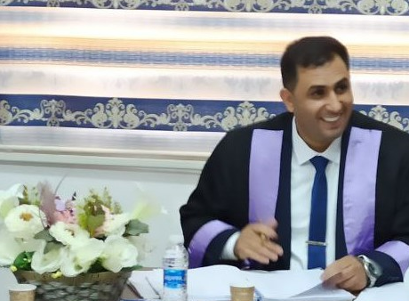
Department of Mathematics and Computer Applications
PERSONAL DATA:
First Name: Ayad Raheem Jalfan:
Telephone Mobile: 07711734648
Telephone Office: 07844544044
Email 1: ayad.raheem@mu.edu.iq Email 2:ayadraheem94@jmail.com
Marital Status: Married
Date of Birth: : 1/April/1986
Gender: Male
Country of Origin: Iraq
Present Nationality: Iraq
Languages and Fluency Level: Arabic and English

EDUCATION:
Degree Earned, Master of Accounting, University of Kufa, College of Administration and Economics
Utilizing Fuzzy Logic to Activate the Performance Focused Activity Based Costing

WORK HISTORY:
- Al-Muthanna University / College of Science / Senior University Lecturer / 1/20/2009
- Director of the Financial Affairs Division

TRAINING AND PROFESSIONAL DEVELOPMENT:
- 2011, University of Baghdad, Administrative Development for Staff and Individuals.
- 2012 Administrative Technical College / University of Baghdad, applications of accounting systems using computers.
- 2014, Al-Muthanna University, Academic Promotions and Promotions Course.
- 2014 College of Science / Al-Muthanna University, computer skills course.
- 2015 United Nations Development Program UNDP / Dhar Center for Development The role of citizens and civil society organizations in recovering the proceeds of corruption.
- 2017 College of Basic Education / Al-Muthanna University, Arabic language safety course.
- 2018 Al-Muthanna University English language testing course.
- 2019 Al-Muthanna University Arabic language testing course.
- 2019 Al-Muthanna University computer testing course.
- 2020 Al-Muthanna University Higher Education Funds Management Course
- 2021 General Syndicate of Human Development Trainers/Baghdad National Certified Trainer (T.O.T) course

