
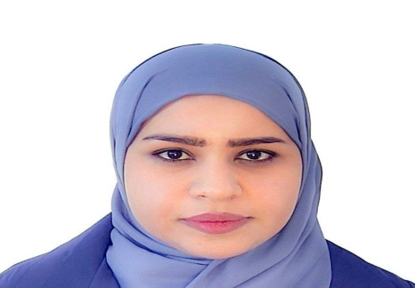

CURRICULUM VITAE

Experience

Two years

Education
Two years at Al-Muthanna University, College of Science

Certifications
MSc
Published research

Solve the Laplace,poisson and telegraph equations using shehu transform

Telephone Mobile : 07804690288

E-Mail: banin6234@gmail.com

Academic account
banenshaker@mu.edu.iq

Languages

Arabic
English
Name: Banin Shaker jubear Date of Birth : 1995\5\ 22

