CURRICULUM VITAE
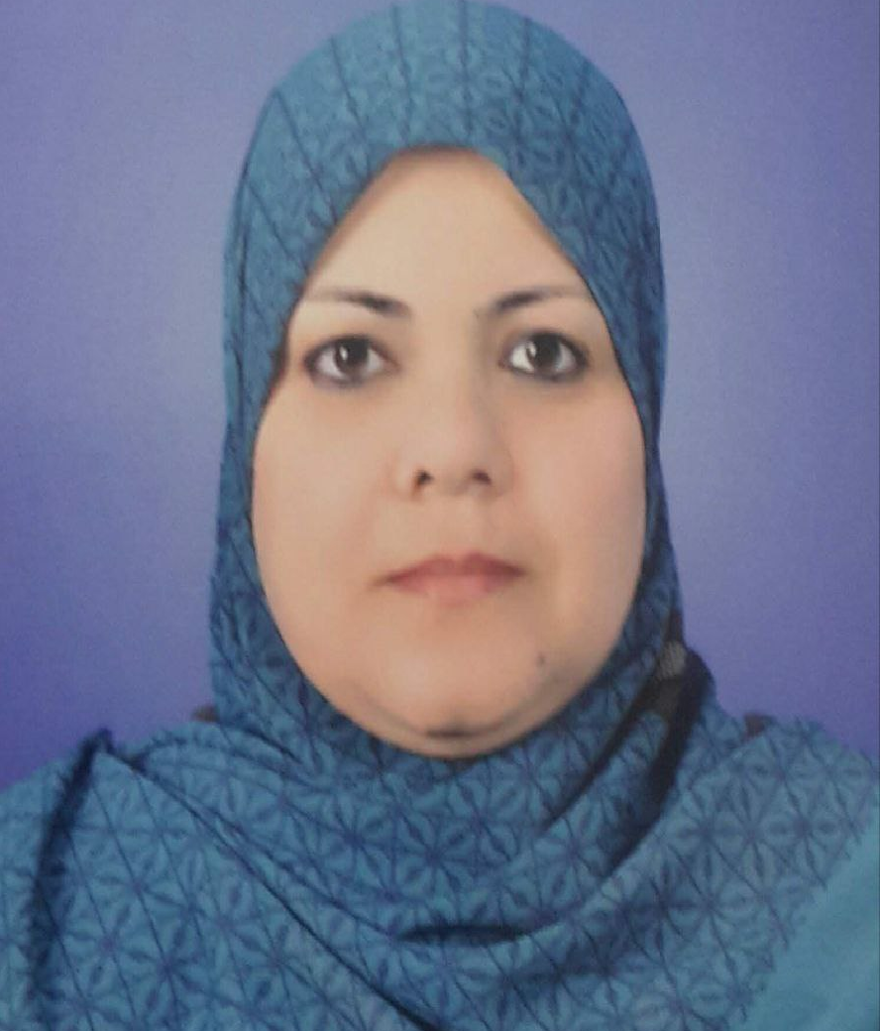
Department of Mathematics and Computer Application

PERSONAL DATA:
First Name:Nidaa Middle Name:Hasan / Other Names: Haji
Telephone Mobile:07810430913
Telephone Office:
Email 1:niaah79@yahoo.com Email 2:
Marital Status:Married
Date of Birth: 17/ February /1979
Gender: Female
Country of Origin: Iraq
Present Nationality: Iraqi
Languages and Fluency Level: Arabic (Native)
-English (intermediate)

EDUCATION:
MSc. Al-Qadisiyah university , Iraq from 09/2009 to 03/2013
Thesis title: On Dimension theory by using feebly open set .

Bsc. Bagdad university , Iraq from 09/1996-1997 to 09/2002-2001

WORK HISTORY:
Lecturer in mathematics, University of Al-Muthanna, College of Sciences, Department of and Lecturer in mathematics Mathematics and Computer Application, Samawa 66001, Iraq, March 2013- Present), Computer Science mathematics with 20+ years’
- Teaching courses in mathematics science.

TRAINING AND PROFESSIONAL DEVELOPMENT:
Course Name, city (Institution, Address), Date

- It is not necessary to list publications or presentations on your CV for purpose of this training.

- Photos on the CV are not necessary

