CURRICULUM VITAE 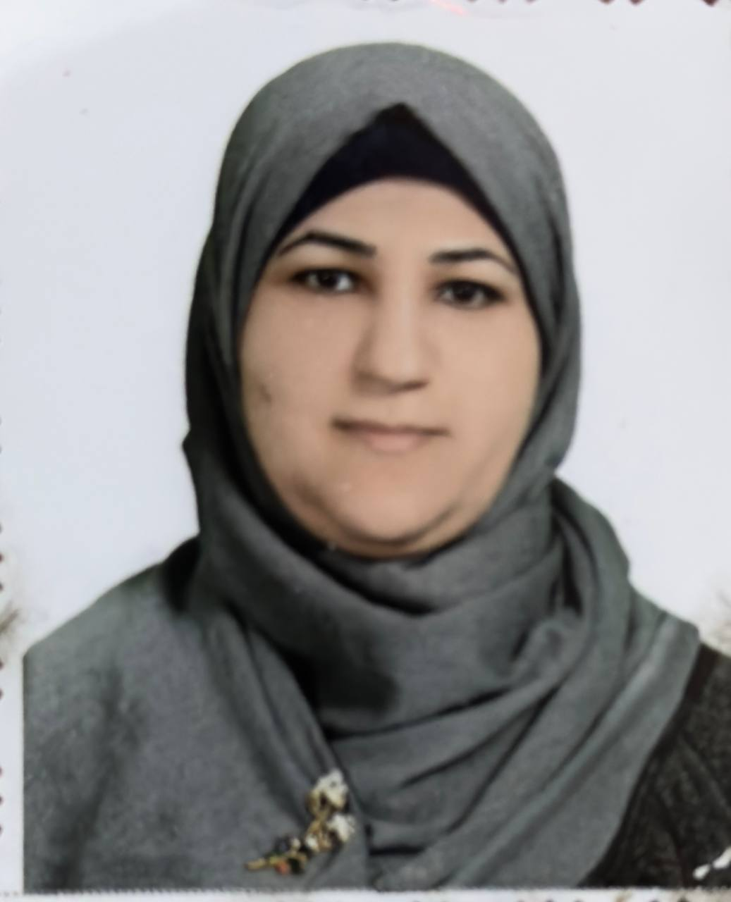

PERSONAL DATA:
First Name:Noor Middle Name Sami / Other Names: Aboud
Telephone Mobile: 07811877178
Telephone Office:
Email 1: drnoor_s78@mu.edu.iq Email 2:
Marital Status:Married
Date of Birth: 28/September/1978
Gender:Femel
Country of Origin: Iraq
Present Nationality:Iraqi
Languages and Fluency Level:Arabic,English

EDUCATION:
Degree Earned, ph.D, College of Medicine/University of Babylon, Iraq,10/2014 to 10/2017

Molecular Detection of Human T Lymphotropic Virus Type-1 (HTLV-1) and Expressional Proteins of CDK4, CDK6, P27 and Bcl-2 in Hodgkinʼs and Non- Hodgkinʼs Lymphomas

WORK HISTORY:
Job Title
-Asst.lecturer from 12/11/2008 to 16/10/2012
-Lecturer from 17/10/2012 to 23/6/2018
-Asst.prof from 24/6/2018 till now

