CURRICULUM VITAE
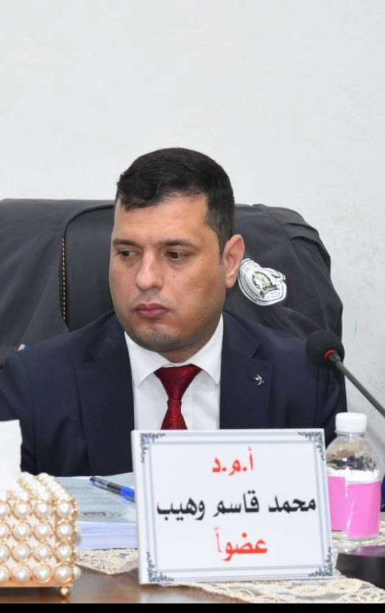
قسم علوم الحياة>>>>>>>

PERSONAL DATA:
First Name: Mohammed Middle Name / Other Names: Qasim Waheeb
Telephone Mobile:+9647808002038
Telephone Office:
Email 1:mhmdkas@mu.edu.iq Email 2:mqassim59@yahoo.com
Marital Status:
Date of Birth: 18/October/1982
Gender: Male
Country of Origin: Iraq
Present Nationality: Arabic
Languages and Fluency Level: Arabic, English and Russian

EDUCATION:
PhD, Thi-QAR University, College of Science, Iraq, 09/2019 to 06/2023.
- عنوان الاطروحة
Study the efficiency of Beauveria bassiana, Trichoderma harzianum fungi and two plant extractions: Tamarix aucheriana, Suaeda verimiculata L. in controlling mosquito Culex pipiens (Diptera:Culicidae) in the Laboratory, in Thi-Qar province, Iraq

WORK HISTORY:
Job Title: Assistant Professor Doctor , Al Muthanna University, Al Muthanna Province, Start and End Date (05/2008).

TRAINING AND PROFESSIONAL DEVELOPMENT:
Course Name, city (Institution, Address), Date

- It is not necessary to list publications or presentations on your CV for purpose of this training.

- Photos on the CV are not necessary

