CURRICULUM VITAE
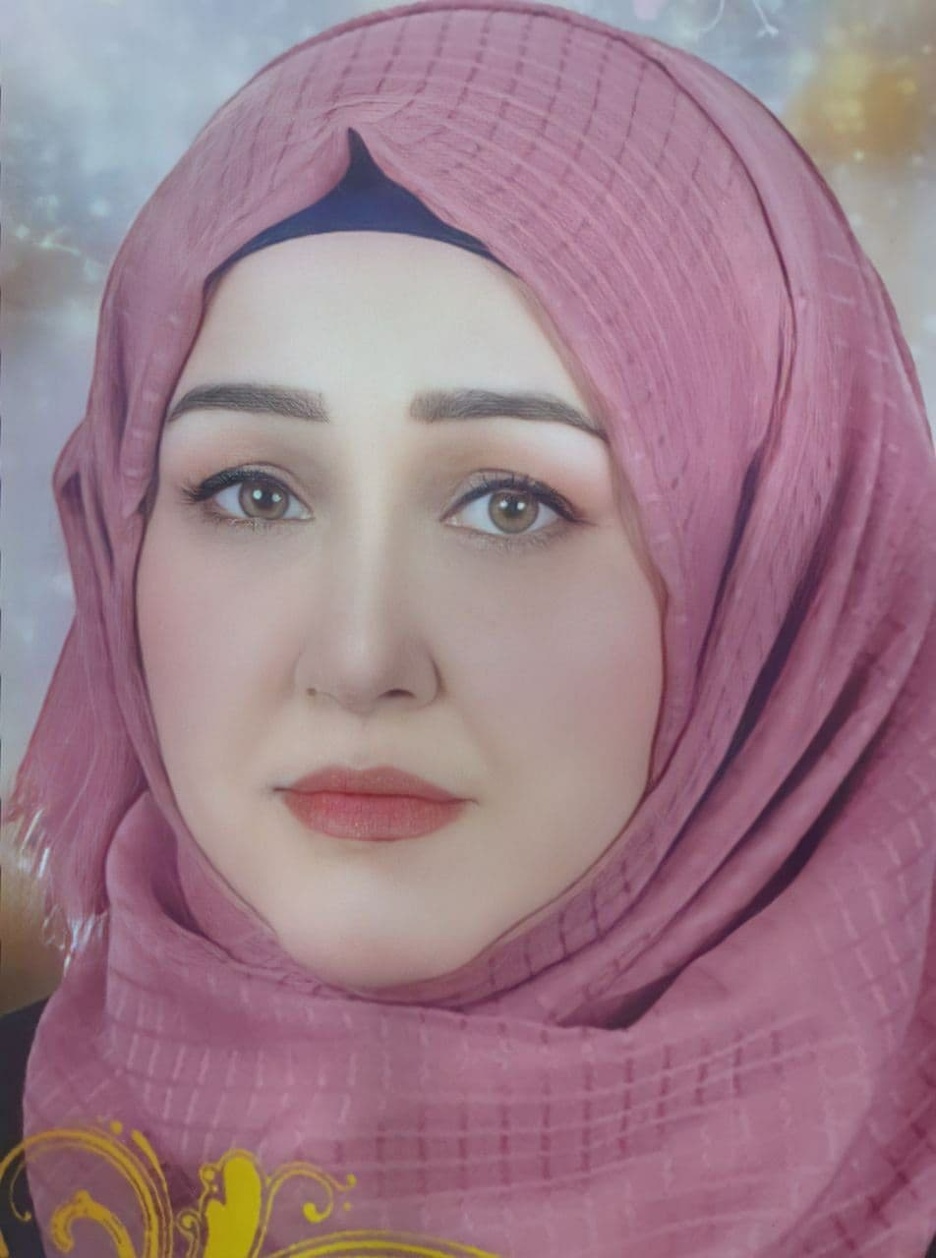
قسم >>>>>>>

PERSONAL DATA:
First Name: hawraa falih wali :
Telephone Mobile:07812291597
Telephone Office:
Email 1: hawraafalih@mu.edu.iq Email 2:
Marital Status:
Date of Birth: 4/February /1984
Gender: female
Country of Origin: iraq
Present Nationality:
Languages and Fluency Level: Arabic

EDUCATION:
Degree Earned, master in microbiology from Babylon university /science of women , Start 1/11/2015 and End 1/11/2017
Example:

- عنوان الاطروحة Study of the Effect CdS and Au/CdS nanoparticles of chemical synthesized on Some Gram-Negative Bacteria on the Molecular Level and Antimicrobial

WORK HISTORY:
Job Title, college professor, Start in teaching 1/5/2018,
Supervisor// professor Ali Hussen Almarzoqi and Ayad Fadhil Alkaim
- Duties and accomplishments

TRAINING AND PROFESSIONAL DEVELOPMENT:
Course Name, city (Institution, Address), Date

- It is not necessary to list publications or presentations on your CV for purpose of this training.

- Photos on the CV are not necessary

