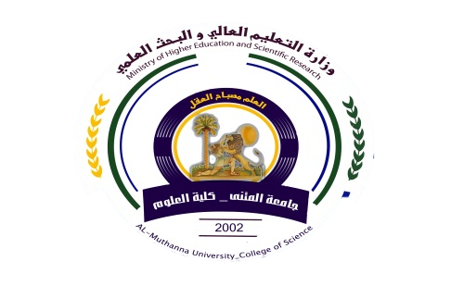
University:AL-Muthana
College:college of science
Department:Biology
Subject:-BiochemistryIII
Stage:fourth
Lecturer name:Muna Hasson
Academic Status; lectural
Qualification:Ph.D in biochemistry

Republic of Iraq
The Ministry of Higher Education
& Scientific Research

49

49

Teaching plan for the semester form(2020-2021)
Course Instructor | Muna Hasson Aboodi
E_mail | Muna.hasson@mu.edu.iq
Title | Biochemistry II
Course Coordinator | One semester(2nd)
Course Objective | This course aims to provide an understanding of the key chemical compounds in metabolism of proteins, carbohydrates and lipids.
Course Description | General introduction to metabolism, how metabolic pathways are investigated and regulated, biosynthesis and oxidation metabolic pathways are discussed. The mechanisms that control metabolic pathways (e.g. feedback inhibition, hormonal regulation). CHO, proteins and lipids metabolism will be discussed.
Textbook | ---
References | 1-Voet D and Voet JG (2011) Biochemistry, 4th Ed.  2-Principles of Biochemistry.Lehninger(2012).6th Ed.
Course Assessment | Term Tests | Laboratory | (Quizzes)  Written exams | Problems sheet | Final Exam
Course Assessment | (23%) | (13%) | (2%) | (2%) | (60%)
General Notes | By the end of this course the student should be able to describe and evaluate the methods used in studying metabolic pathways and the enzymes and cofactors involved, Discuss the mechanisms used to study enzymes, and the mechanisms enzymes use to drive reactions.
University:AL-Muthana
College:college of science
Department:chemistry
Subject:-BiochemistryIII
Stage:fourth
Lecturer name:Muna Hasson
Academic Status; lectural
Qualification:Ph.D in biochemistry

Republic of Iraq
The Ministry of Higher Education
& Scientific Research

49

Teaching plan for the semester form(2021-2022)
week | Date | Topics Covered | Lab. Experiment Assignments | Notes
1 | 27-2-2022 | Introduction of metabolism, | Lipase
2 | 7-3-2022 | Types Of Biochemical Reactions | Glycogen
3 | 14-3-2022 | Regulation of Metabolic Pathways | Biochemistry of Saliva
4 | 21-3-2022 | Cellular forms of chemical energy | The detection of АTP in various tissues.
5 | 28-3-2022 | Glycolysis | Detection of lactic acid in muscular tissue.
6 | 4-4-2022 | Gluconeogenesis | the formation and oxidation of ketone bodies in the body tissues.
7 | 11-4-2022 | Glycogen biosynthesis | Determination of milk acidity
8 | 18-4-2022 | Respiratory chain | Alcoholic Fermentation in Yeasts
9 | 25-4-2022 | Citric acid cycle | pH of biological liquids
10 | 2-5-2022 | Fatty acid catabolism | Isolation of Casein, Lactose, and Albumin from Milk
11 | 9-5-2022 | Amino acid catabolism | The Chemistry of Milk
12 | 16-5-2022 | Lipid biosynthesis | Catalase
13 | 23-5-2022 | Oxidative phosphorylation | Chemical Digestion of Nutrients.Fats
14 | 30-5-2022 | Nucleotides biosynthesis | Chemical Digestion of Nutrients.Carbohydrates
15 | 4-6-2022 | Nucleotide Metabolism | Chemical Digestion of Nutrients.Proteins

Instructor Signature: Dean Signature:
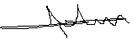
Muna Hasson Aboodi

