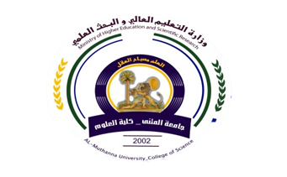
University:Al-Muthana
College:Science
Department: chemistry
Stage:Fourth
Lecturer name: duha majeed
Academic Status:
Qualification: Msc
Place of work: Al-Muthana University/
College of Science.

Republic of Iraq
The Ministry of Higher Education
& Scientific Research

Teaching plan for the semester form2022-2023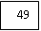
Course Instructor | Duha majeed
E_mail | Dhuha .majeed @mu.edu.iq
Title | Natural products
Course Coordinator | First course
Course Objective | Students definition of natural products
Course Description | The chemistry of natural products course aims to clarify what are the two types of natural products (primary and secondary metabolites) and their most important natural sources (animal, plant, microorganisms or marine organisms), their classification, methods of extraction, separation and purification from their natural sources, and a description of their chemical composition and methods of synthesis, biological, laboratory and active.Balogism and the relationship of baculostatic activity to its chemical composition) and what are the most important families of organic chemical compounds representing each type and the difference between them and the rest of the organic compounds.
Textbook
References
Course Assessment | Term Tests | Laboratory | Quizzes | Project | Final Exam
Course Assessment | 40% |  |  |  | 60%
General Notes | Type here general notes regarding the course

University:Al-Muthana
College:Science
Department: chemistry
Stage:Fourth
Lecturer name: duha majeed
Academic Status:
Qualification:Mcs
Place of work: Al-Muthana University/ College of Science

:
Place of work:

Republic of Iraq
The Ministry of Higher Education
& Scientific Research

49

Teaching plan for the semester form
week | Date | Topics Covered | Lab. Experiment Assignments | Notes
1 | 2/10/2022 | Introduction about natural products
2 | 9/01/2022 | Separation of natural products
3 | 16/10/2022 | turbines
4 | 10/23/2022 | Separation of turbines
5 | 30/01/2022 | Tannians
6 | 6/11/2202 | Separation of tannins
7 | 13/11/2022 | Kumarin s
8 | 1/201/2022 | Alkaloid
9 | 27/11/2022 | Classification of alkaloid
10 | 4/12/2202 | flavonoids
11 | 11/12/2202 | phenols
12 | 18/12/2022 | Volatile oils
13 | 25/12/2022 | Importance of volatile oils
14 | 1/1/3202 | vitamins
15 | 8/1/2023 | Importance of vitamins

Instructor Signature: Dean Signature:

