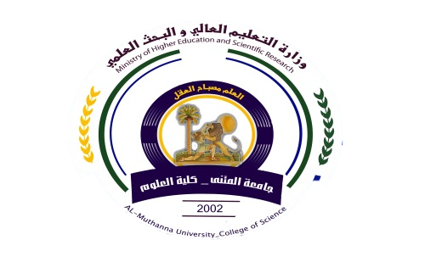
University:AL-Muthana
College:college of science
Department:chemistry
Subject:-BiochemistryIII
Stage:fourth
Lecturer name:Muna Hasson
Academic Status; lectural
Qualification:Ph.D in biochemistry

Republic of Iraq
The Ministry of Higher Education
& Scientific Research

49

49

Teaching plan for the semester form(2020-2021)
Course Instructor | Muna Hasson Aboodi
E_mail | Muna.hasson@mu.edu.iq
Title | Biochemistry III
Course Coordinator | One semester(1st)
Course Objective | This course aims to provide an understanding of the key chemical compounds in metabolism of proteins, carbohydrates and lipids.
Course Description | General introduction to metabolism, how metabolic pathways are investigated and regulated, biosynthesis and oxidation metabolic pathways are discussed. The mechanisms that control metabolic pathways (e.g. feedback inhibition, hormonal regulation). CHO, proteins and lipids metabolism will be discussed.
Textbook | ---
References | 1-Voet D and Voet JG (2011) Biochemistry, 4th Ed.  2-Principles of Biochemistry.Lehninger(2012).6th Ed.
Course Assessment | Term Tests | Laboratory | (Quizzes)  Written exams | Problems sheet | Final Exam
Course Assessment | (23%) | (13%) | (2%) | (2%) | (60%)
General Notes | By the end of this course the student should be able to describe and evaluate the methods used in studying metabolic pathways and the enzymes and cofactors involved, Discuss the mechanisms used to study enzymes, and the mechanisms enzymes use to drive reactions.
University:AL-Muthana
College:college of science
Department:chemistry
Subject:-BiochemistryIII
Stage:fourth
Lecturer name:Muna Hasson
Academic Status; lectural
Qualification:Ph.D in biochemistry

Republic of Iraq
The Ministry of Higher Education
& Scientific Research

49

Teaching plan for the semester form(2022-2023)
week | Date | Topics Covered | Lab. Experiment Assignments | Notes
1 | 6-10-2022 | Introduction of metabolism, glycolysis | Lipase
2 | 13-10-2022 | Fate of pyruvate under aerobic and anaerobic condition | Glycogen
3 | 20-10-2022 | Gluconeogensis | Biochemistry of Saliva
4 | 27-10-2022 | Pentose phosphate pathway,regulation of glycolysis and gluconeogensis | The detection of АTP in various tissues.
5 | 3-11-2022 | Glycogen synthesis and breackdown,regulation of glycogen metabolism | Detection of lactic acid in muscular tissue.
6 | 10-11-2022 | Citric acid cycle,regulation of TCA | the formation and oxidation of ketone bodies in the body tissues.
7 | 17-11-2022 | Oxidation of fatty acids | Determination of milk acidity
8 | 24-11-2022 | Ketone bodies | Alcoholic Fermentation in Yeasts
9 | 31-11-2022 | Fatty acids biosynthesis | pH of biological liquids
10 | 7-12-2022 | Biosynthesis of triacylglycerols and cholesterol | Isolation of Casein, Lactose, and Albumin from Milk
11 | 14-12-2022 | Proteins metabolism-oxidation of amino acid, | The Chemistry of Milk
12 | 21-12-2022 | Urea cycle,pathways of amino acid degradation | Catalase
13 | 28-12-2022 | Degradation of amino acids to pyruvate | Chemical Digestion of Nutrients.Fats
14 | 3-1-2023 | Convert of amino acids to glucose or to ketone bodies | Chemical Digestion of Nutrients.Carbohydrates
15 | 10-1-2023 | Biosynthesis of amino acids | Chemical Digestion of Nutrients.Proteins

Instructor Signature: Dean Signature:
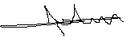
Muna Hasson Aboodi

