
University: Almuthana
College: Science college
Department: Biology
Stage: 2nd
Lecturer name: Emad Abd Atia
Academic Status: Assist Lecturer
Qualification: Master
Place of work: science college

Republic of Iraq
The Ministry of Higher Education
& Scientific Research

49
Teaching plan for the semester form
Course Instructor | Emad Abd Atia
E_mail | Emadabd2210@gmail.com
Title | Plants Groups
Course Coordinator | First
Course Objective | To give the students formation about plants groups and there activity with the environment. genetic transmission happens between parents and offspring and its mechanism
Course Description | Study of alga classification, types of chloroplasts, vegetative characters, types of reproduction, methods of nutrition... etc
Textbook | Nonflowering plants - Qaser Najeeb  Seed and no seed plants – D. Hussein Ali Alsaeedi
References | By the net lectures of, college of science of Babylon university, college of science of Diyala University, King Abdullah University of Science and Technology (KAUST) Saudi Arabia.
Course Assessment | Term Tests | Laboratory | Quizzes | Project | Final Exam
Course Assessment | 20% | 13% | 3% | 4% | 60%
General Notes | non

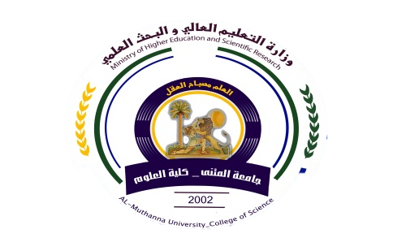
University: Almuthana
College: Science college
Department: Biology
Stage: 2nd
Lecturer name: Emad Abd Atia
Academic Status: Assist Lecturer
Qualification: Master
Place of work: science college

Republic of Iraq
The Ministry of Higher Education
& Scientific Research

49

Teaching plan for the semester form
week | Date | Topics Covered | Lab. Experiment Assignments | Notes
1 |  | Introduction | Types of chloroplast and forms of alga
2 |  | Division: Cyanophyta | Study some genes
3 |  | Division : Chlorophyta | Study some genes
4 |  | Division :Charophyta | Study some genes
5 |  | Division : Euglenophyta | Study some genes
6 |  | Division : Chrysophyta | Study some genes
7 |  | Division: Phaeophyta | Study some genes
8 |  | First exam | First exam
9 |  | Division: Phaeophyta | Study some genes
10 |  | Division: Rhodophyta | Study some genes
11 |  | Bryophyta | Study some genes
12 |  | Division: Ptreridophyta | Study some genes
13 |  | Economic important of alga
14 |  | Second exam

Instructor Signature: Dean Signature:

