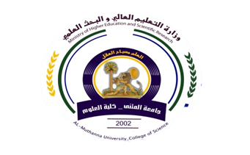
University:
College:
Department:
Stage:
Lecturer name:
Academic Status:
Qualification:
Place of work:

Republic of Iraq
The Ministry of Higher Education
& Scientific Research

49
Teaching plan for the semester form
Course Instructor | Amer Basim Shaalan
E_mail | ame72r@gmail.com
Title | ElectromagnetismII
Course Coordinator | 15- weeks, 3- hours per week
Course Objective | Get knowledge of static magnetism and magnetic laws and Maxwell equations and wave propagation
Course Description | Ampere law, Faraday law, Maxwell equations, wave equation and pointing vector
Textbook | Electromagnetism by Reitz
References | Electromagnetics by Schumm
Course Assessment | Term Tests | Laboratory | Quizzes | Project | Final Exam
Course Assessment | (30%) | - | (10%) | ---- | (60%)
General Notes

University:
College:
Department:
Stage:
Lecturer name:
Academic Status:
Qualification:
Place of work:

Republic of Iraq
The Ministry of Higher Education
& Scientific Research

49

Teaching plan for the semester form
week | Date | Topics Covered | Lab. Experiment Assignments | Notes
1 | 19/2 | Magnetic fields and Magnetism
2 | 1/3 | Biot-Savart law
3 | 7/3 | Ampere law
4 | 14/3 | Forces of magnetic fields and Torques
5 | 21/3 | Microscopic view of magnetization
6 | 28/3 | Inductance and farady law
7 | 4/4 | Maxwell equations in free space
8 | 11/4 | Maxwell equations in matter
9 | 18/4 | Poynting vector
10 | 25/4 | Wave equation
11 | 2/5 | Wave equation problems
12 | 9/5 | Phasor notations of Maxwell equation and wave propagation
13 | 16/5 | Phasor notations of Maxwell equation and wave propagation
14 | 23/5 | Exercise
15 |  | Solve problems

Instructor Signature: Dean Signature:

