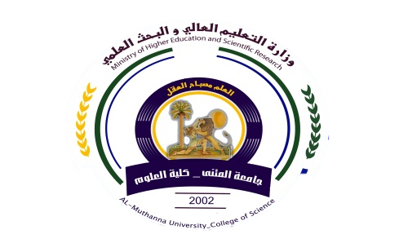
49

University:ALMUTHANNA
College:science
Department: Physics
Stage: Fourth Year Physics
Lecturer name: Salah .A.hassan
Academic Status:Assi.Taecher
Qualification:Master degree
Place of work:physic Department

Republic of Iraq
The Ministry of Higher Education
& Scientific Research

Course Weekly Outline

Course Instructor | Salah Abdulkhudher hassan
E_mail | salahramatha@yahoo.com
Title | Solid state PhysicsII
Course Coordinator | The Fourth stage
Course Objective | Teach students the most important basic concepts, principles, laws, and scientific theories of the Solid state Physics, the student has the scientific skills that enable him to perform their professional and business functions, and others.
Course Description

Textbook | فيزياء الحالة الصلبة تاليف الدكتور مؤيد جبرائيل يوسف  فيزياء الحالة الصلبة تأليف الدكتور يحيى الجمال
References | فيزياء الحالة الصلبة تاليف الدكتور غازي ياسين القيسي
Course Assessment | Term Tests | Laboratory | Quizzes | Project | Final Exam
Course Assessment | As (35%) |  | (5%) | ---- | (60%)
General Notes | Type here general notes regarding the course

University: ALMUTHANNA
College: science
Department: Physics
Stage: Fourth Year Physics
Lecturer name:Salah .A.Hassan
Academic Status:
Qualification:
Place of work:

Republic of Iraq

The Ministry of Higher Education
& Scientific Research

49

Course weekly Outline
week | Date | Topics Covered | Lab. Experiment Assignments | Notes
1 |  | Chapter one/Electrical Properties of solid  1- Electrical Conductivity  2- Metal  3- Energy distribution functions  4- Maxwell-Boltzmann distribution  5- Bose-Einstein distribution  6- Fermi-Dirac distribution
2 |  | 7- Electron Conductivity in Metals  8- Classical Free electron model  9- Drude Theory for Free Electron Conductivity
3 |  | 10- Quantum Theory of free Electron Gas  11- Ideal Fermi – Dirac Gas  12- Fermi – Dirac function  13- Electronic levels in one dimension  14- - Electronic levels in three dimension
4 |  | 15- Density of states in 3D  16- Fermi energy level at T=0 K  17- Electron velocity at Fermi surface  18- kinetic energy in 3D
5 |  | 19- Sommerfeld Theory for Electrical Conductivity  Chapter two  1- Band Theory
6 |  | 2- Periodic Potential and Bloch Theory  3- General properties of Bloch Theory
7 |  | 4- Energy band according to Bloch Theory  5- Brillouin Zones in Band Theory
8 |  | 6- Kronig- Penny Model
9 |  | Chapter three/Semiconductors  1- Intrinsic Semiconductors  2- Concentration of electrons and holes in semi- conductor
10 |  | 3- Doping of Semiconductors  4- Concentration of electrons and holes in dopped Semiconductors  5- Hall effect
11 |  | Chapter four/  1- Magnetic Properties of Solid  2- Magnetic dipole momentum
12 |  | 3- Magnetization  4- Magnetic susceptibility  5- Permeability
13 |  | 6- Classification of Magnetic Materials  7-Diamagntic Materials  8- Langevin Diamagnetism Theory
14 |  | 9- Paramagnetic Materials  10 -Quantum Theory of Paramagnetism
15 |  | 11- Ferromagnetic Materials
Instructor Signature: Dean Signature:

