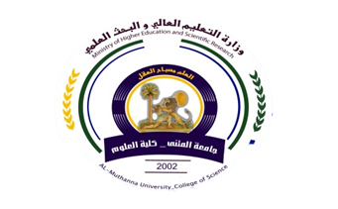
University:AlMuthanna
College:scienc
Department:physicis
Stage:2nd
Lecturer name:Nahedh Hesson
Academic Status:Dr
Qualification:
Place of work: scienc College

Republic of Iraq
The Ministry of Higher Education
& Scientific Research

49
Teaching plan for the semester form
Course Instructor
E_mail | @gmail.comNahedhalwash61
Title | Materials science
Course Coordinator | 15th weeks
Course Objective | Materials Science, Materials properties ,crystal structure ,heat treatment
Course Description | Materials Science, Materials properties ,crystal structure ,heat treatment
Textbook | Series in Materials Science and Engineering  Brian Cantor &Fionn Dunne
References | Sintering SUK-JOONG L.KANG  CERAMIC MATERIALS Science and Engineering  C.BARRY CARTER .M .GRANT NORTON
Course Assessment | Term Tests | Laboratory | Quizzes | Project | Final Exam
Course Assessment | (30%) | - | ----- | (10%) | (60%)
General Notes | Type here general notes regarding the course

University:Almuthanna
College: scienc
Department:physicies
Stage:2nd
Lecturer name:Nahedh Hasson
Academic Status:Dr
Qualification:
Place of work: :physicies Departmen

Republic of Iraq
The Ministry of Higher Education
& Scientific Research

49

Teaching plan for the semester form of Materials
week | Date | Topics Covered | Lab. Experiment Assignments | Notes
1 | 21-2 | Introduction in materials scienc
2 | 1/3 | Bonds
3 | 8/3 | Characteristics of Materials
4 | 15/3 | Crystal Structure of Material
5 | 22/3 | Crystal Factors
6 | 29/3 | Crystal Plan
7 | 5/4 | Crystal Factors & Crystal Plan
8 | 12/4 | Crystal of Defects
9 | 19/4 | Mattel alloys
10 | 26/4 | Physical properties of materials
11 | 3/5 | Heat treatment &the effect on properties
12 | 10/5 | Sintering
13 | 17/5 | Introduction on ceramic
14 | 24-5 | Polymers
15 |  | Vulcans of rubber

Instructor Signature: Dean Signature:

