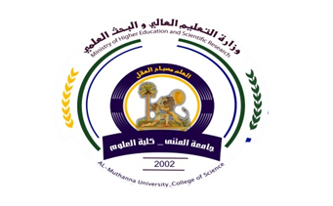
Republic of Iraq
The Ministry of Higher Education
& Scientific Research

University:
College:
Department:
Stage:
Lecturer name:
Academic Status:
Qualification:
Place of work:

49
Teaching plan for the semester form
Course Instructor | Nedaa Hassan Haje
E_mail | Nedaa@yahoo.com
Title | Mathematics
Course Coordinator
Course Objective | The study of mathematics concerning the study of physics by  Focusing on the concepts and functions used in the task of physics .
Course Description

Textbook | Thomas , Calculus
References | Calculus and analyttical geometry
Course Assessment | Term Tests | Laboratory | Quizzes | Project | Final Exam
Course Assessment | 35% |  | 5% | ---- | 60%
General Notes

Republic of Iraq
The Ministry of Higher Education
& Scientific Research

University:
College:
Department:
Stage:
Lecturer name:
Academic Status:
Qualification:
Place of work:

49

Teaching plan for the semester form
week | Date | Topics Covered | Lab. Experiment Assignments | Notes
1 |  | Function
2 |  | Combining of function
3 |  | Shifting
4 |  | Limits
5 |  | Continuity
6 |  | Trigonomettic function
7 |  | The concept of limit
8 |  | Def. differentiation, and diff. rules.
9 |  | Derivative of trigonomatric function
10 |  | Chain rule ,Implicit diff
11 |  | Applications of derivative
12 |  | Extreme values
13 |  | Absolut max and absolut min
14 |  | Concave up concave down
15 |  | Inflection point

Instructor Signature:Nedaa Hassan Haje Dean Signature:

