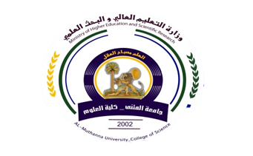
Republic of Iraq
The Ministry of Higher Education
& Scientific Research

University:Al-Muthanna
Faculty :Science
Department:Biology
Stage: MSc. Students
Lecturer name: Faiq H.Alradi
Academic Status:
Qualification:
Place of work:Al-MuthannaUniversity/
College of Science.

Teaching plan for the semester form
Course Instructor | Prof. Dr. Faiq H. Alradi
Email | Faiq_alradi73@mu.edu.iq
Title | Adv. Plant physiology
Course Coordinator | 15 weakes,2 hour per weak
Course Objective | Identify the metabolic processes and activities that take place at the cellular level, as well as the biochemical reactions that contribute to increased growth, which positively impacts plant production.
Course Description | The curriculum vocabulary explains the properties of water and its contributions to cellular interactions, in addition to highlighting the mechanism of water withdrawal and transfer from the soil to the plant...
Textbook
References | Plant physiology and development 2018.  New papers and researchers in this line.  .
Course Assessment | Term Tests | Quizzes | Project | Final Exam
Course Assessment | 27% | 3% | -- | 70
General Notes

University:Al-Muthanna
Faculty :Science
Department: Biology
Stage: M.Sc. Students
Lecturer name:
Academic Status:
Qualification:.
Place of work:Al MuthannaUniversity/Faculty of Science

:
Place of work:

Republic of Iraq
The Ministry of Higher Education
& Scientific Research

49

week | Date | Topics Covered | Notes
1st |  | Introduction of plant physiology
2nd |  | Characteristic of water
3rd |  | Transport of solutes
4th |  | Mineral nutrition
5th |  | Transport of ions and across cell membrane
6th |  | Photosynthesis: Light reactions
7th |  | Photosynthesis: Dark reactions
8th |  | Respiration
9th |  | Hormones : Auxins
10th |  | Geberlines
11th |  | Cytokinins
12th |  | Ethylene
13th |  | ABA
14th |  | Enzymes
15th |  | EXAM
Teaching plan for the semester form

Instructor Signature: Dean Signature:
Prof. Dr. Faiq H. Alradi

