University: Muthanna
College: College of Science Department: Environment and pollution
Stage: third
Lecturer name:Athier Hussin
Academic Status:lecturer
Qualification: MSc
Place of work:studies desert center .

Republic of Iraq
The Ministry of Higher Education
& Scientific Research

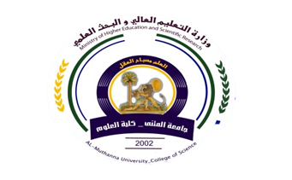

49
Teaching plan for the semester form
Course Instructor | Athier Hussin
E_mail | Samawea_1234@yahoo.com
Title | Natural resources and the management of protected areas
Course Coordinator | First semester
Course Objective | The student's knowledge of natural resources and their importance and protection through management
Course Description | Protection of the environment and natural resources, proper management of these resources in terms of use and provide the necessary conditions for sustainability
Textbook | /
References | Environmental problems, scientific research published, Internet
Course Assessment | Term Tests | Laboratory | Quizzes | Project | Final Exam
Course Assessment | As (34%) |  | As (6%) | ---- | As (60%)
General Notes

University: Muthanna
College: College of Science Department: Environment and pollution
Stage: third
Lecturer name:Athier Hussin
Academic Status:techer
Qualification:MSc
Place of work:

Republic of Iraq
The Ministry of Higher Education
& Scientific Research

49

Teaching plan for the semester form
week | Date | Topics Covered | Lab. Experiment Assignments | Notes
1 | 2/10/2016 | Definition of natural resources  + Classification of natural resources
2 | 11/10/2016 | Mineral resources management, natural gas and radioactive minerals
3 | 18/10/2016 | Renewable resources and alternative energy management
4 | 25/10/2016 | Management of water resources and the optimum exploitation
5 | 1/11/2016 | natural resource management that use in the industry
6 |  | Climate change and its impact on natural resources
7 |  | Depletion of natural resources+ Sustain natural resources
8 |  | Exam the first month
9 |  | The definition of the term natural reserves +  Rankings of nature reserves
10 |  | Terms and conditions of natural reserves
11 |  | Geographical distribution of natural reserves around the world
12 |  | Reserves natural wild environment and its management
13 |  | Managements of natural marine environment
14 |  | The role of natural reserves in maintaining the ecological balance
15 |  | Examination of the second month

Instructor Signature: Dean Signature:

