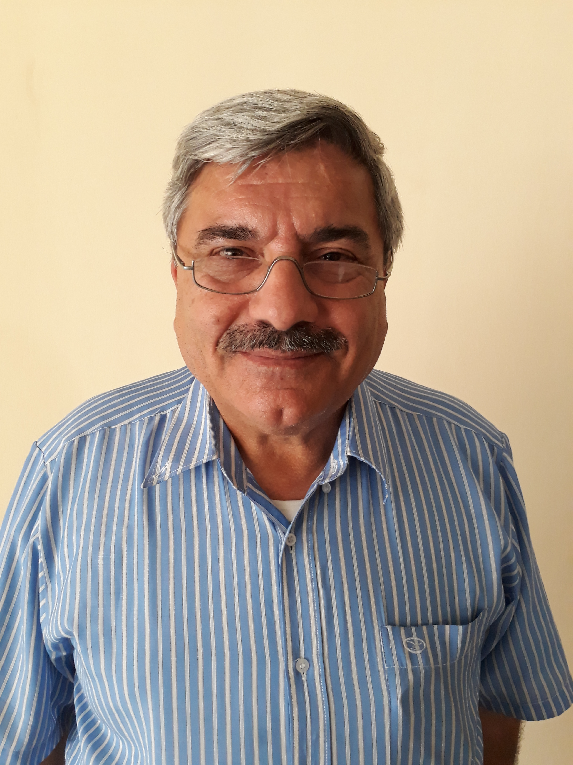
Full Name: Ali Mohammed Rashid Obayda Alnasrawi
Place of Birth: Baghdad
Date of Birth: 5-1-1955
Nationality: Iraqi
Language: Arabic , French, German, English and Italian
Place of work: Physics Department, Science Faculty, Al-Muthanna University,
66001Samawa, IRAQ.
Mobile No.: +9647808340588 ; +9647716236783
E-mail: dralialnasrawi@gmail.com, alimah@mu.edu.iq,

ACADEMIC SCIENTIFIC RANK

- Lecturer

FELLOWSHIP

QUALIFICATION

- Doctor in Materials Sciences , Faculty of Sciences and Technology, Nancy University, Nancy, France (1983).

Title of the PhD Thesis

Study of Amorphous Alloys of Ni-B obtained by electrolytic Method, Physical Properties Preparation-Phase transition Amorphous Crystal-Structure
Title of the MSc Thesis

Study of Chemical and Electrolytic Amorphous Deposits of Ni-B
POSITION HELD

Since 21/1/2014 Lecturer-Dep. of Physics-Fac. Of Science
21/9/2014-22/9/2015 Head of Dep. of Physics-Fac. of Science.
Since 4/4/2016 Director of Dep. Of Studies, Planning and Follow-up

COURSES TAUGHT

- UNDER GRADUATE

Department | Study Stage | Subject | No.
Chemistry | First | Electricity and Electromagnetics | 1
Physics | First | Mechanics & Properties of Materials | 2
Physics | First | English Language | 3

- POSTGRADUATE

Department | Study Stage | Subject | No.
Chemistry | First | Electricity and Electromagnetics | 1
Physics | First | Mechanics & Properties of Materials | 2
Physics | First | English Language | 3

Department | Study Stage | Subject | No.
Physics | MSc | Research Methods | 4

- PUBLICATIONS

PAPERS
1 | Electrolytic Amorphous Deposits of Ni-B , Bulletin de la Societe Chimique de France, I257-I261 , 1982
2 | Amorphous Binary Alloys obtained by electrolytical and chemical methods, Materials Chemistry and Physics, (11) 1984 453-459.
3 | Variation in the Resistivity and Temperature Coefficient of Resistivity of Amorphous Ni-B Layers during the phase transition, Journal of Material Science, GB,1985,Vol.20,No.9, P.3305-10

- CONFERENCES

1
2

