Curriculum Vitae
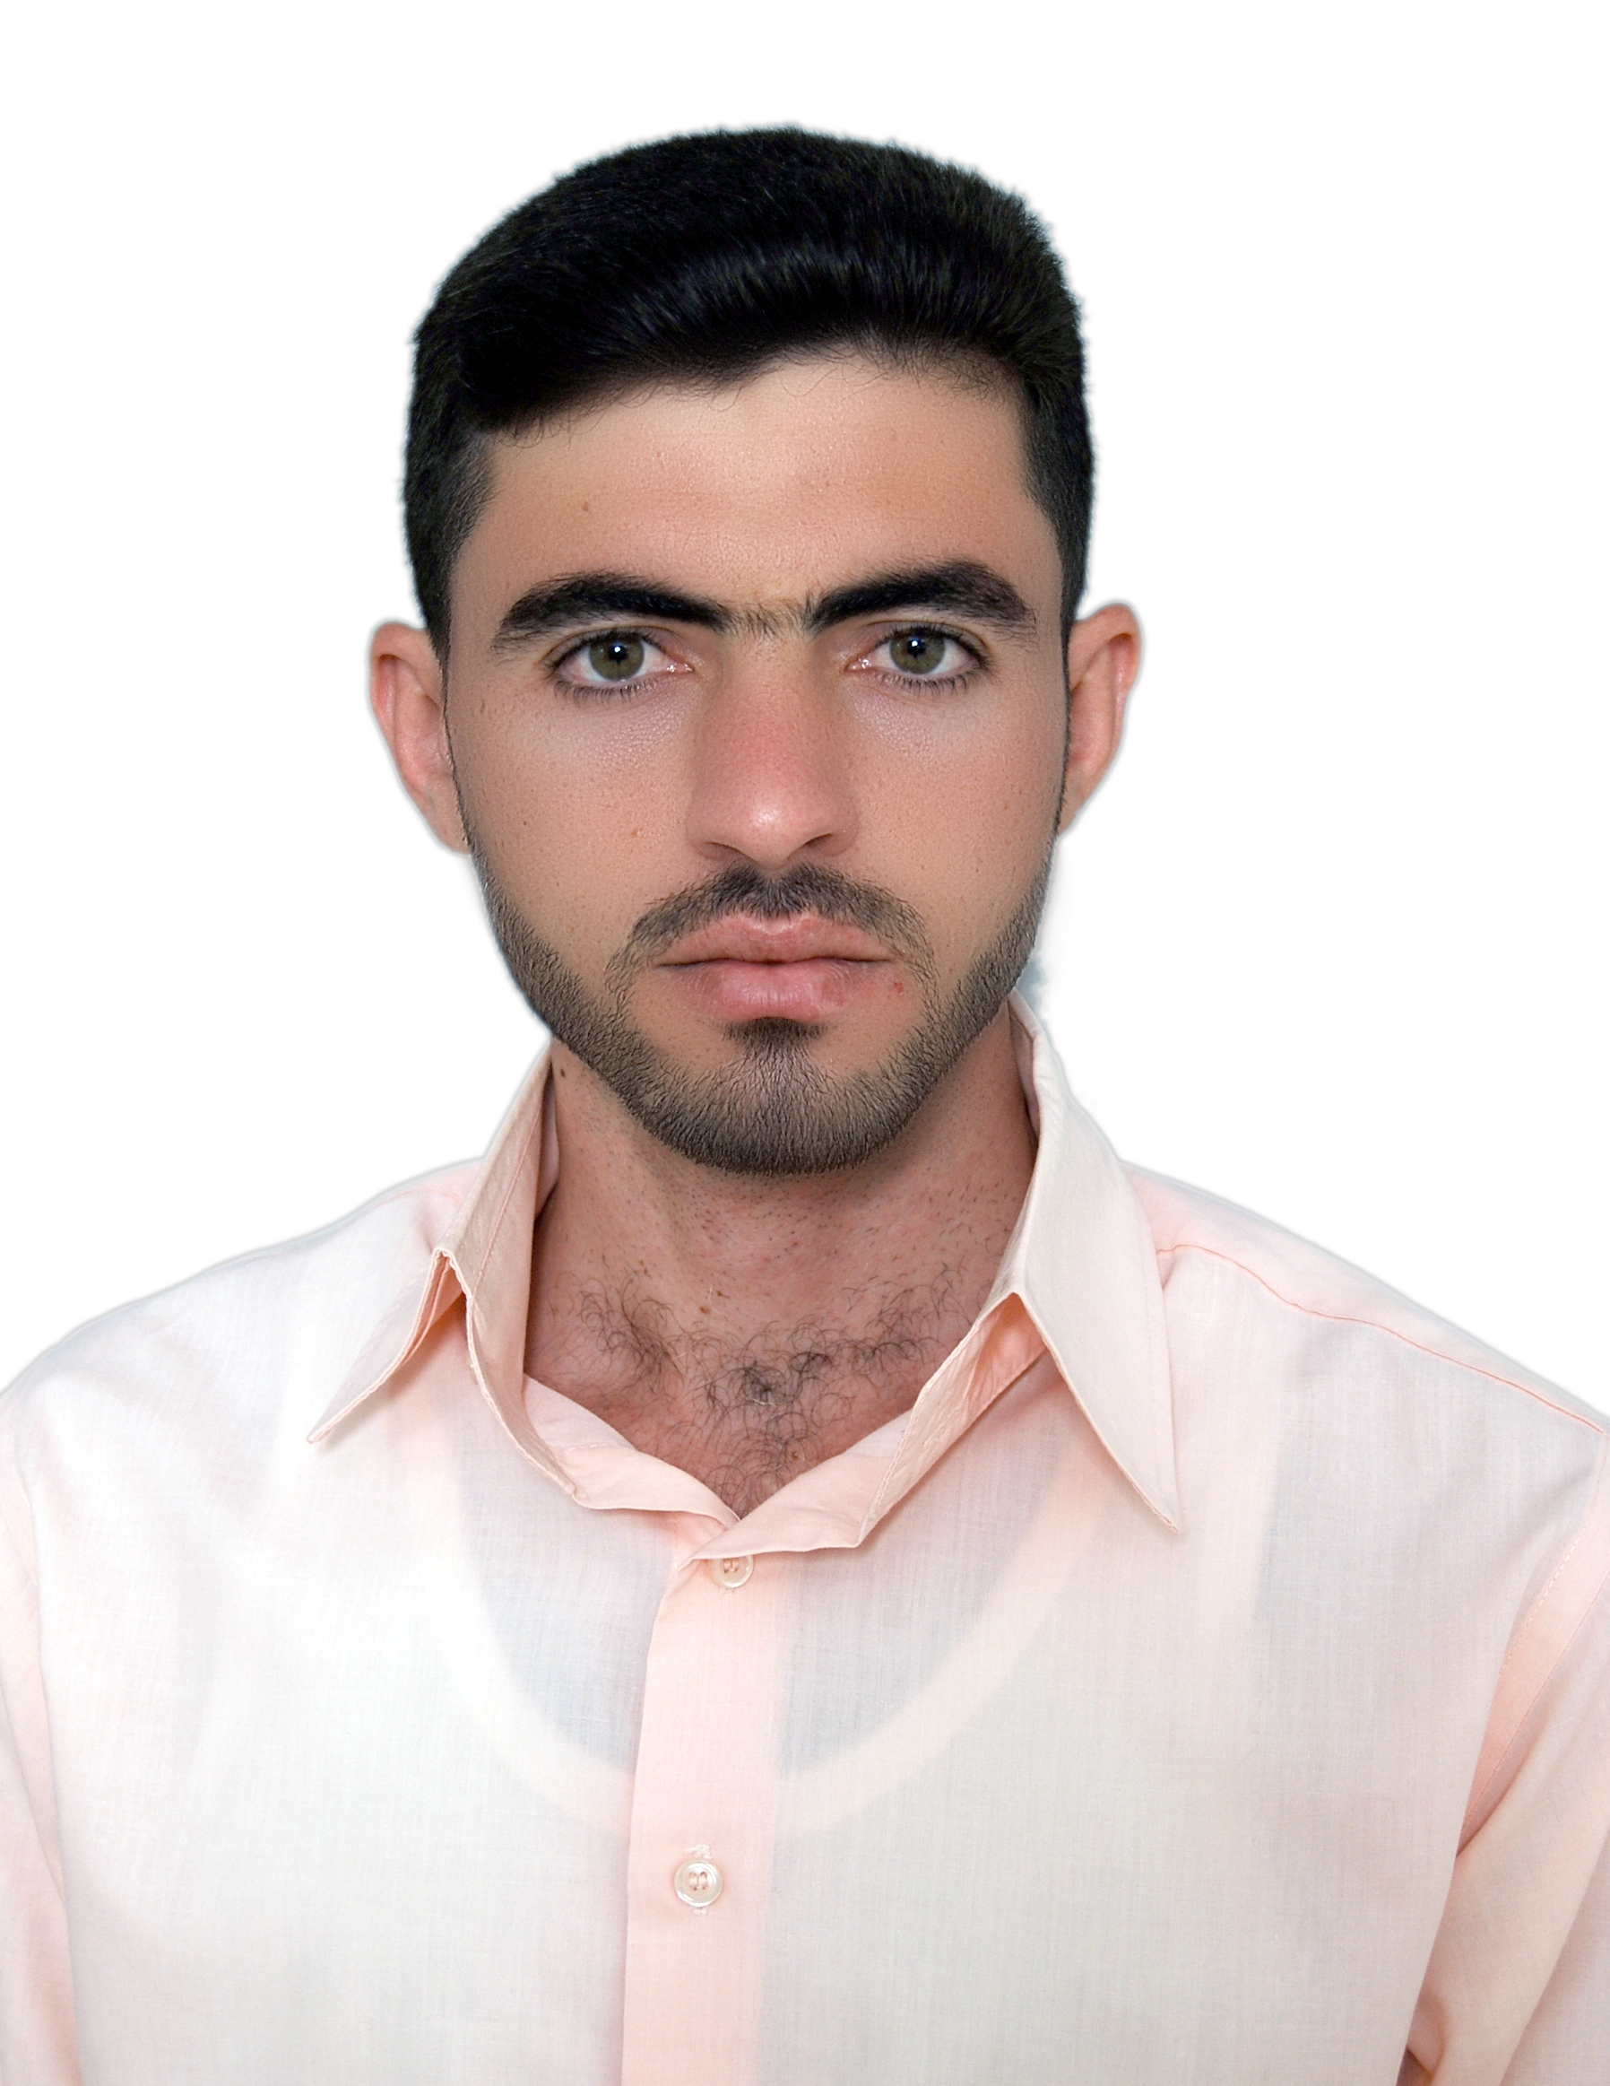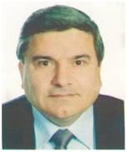

Photo

Name: Ali Nadhim Sabbar
Date of Birth: 1984
Specialization: Theoretical Physics
Position: Semawah/ Iraq
Scientific Degree: Master
Work Address: Mathematics Department, College of Science, Al-Muthanna University
Work Phone:
Mobile: 07812701984
E-mail: asabbar12@yahoo.com

1- Scientific Certification

Date | College | University | Degree science
2008 | Science | Muthanna-Iraq | B.Sc.
2013 | Science | Rudn-Russia | M.Sc.
 |  |  | Ph.D.
 |  |  | Any other

From –To | Workplace | Career | No.
2008-2010 | College of Science, Al Muthanna Univ. France | Researcher | 1
2013-on | College of Science, Al Muthanna Univ. | Lecturer | 2
 |  |  | 3
 |  |  | 4
 |  |  | 5
 |  |  | 6
- 2- Career

- 3- University Teaching
From -To | The (Institute / College) | University | No.
2013-on | Science | Al-Muthanna | 1
 |  |  | 2
 |  |  | 3
 |  |  | 4
 |  |  | 5
 |  |  | 6
 |  |  | 7

- 4- Courses Which You Teach
Year | Subject | Department | No.
2008-2014  222  20 | Lab. Atomic physics | Physics | 1
2008-2014 | Lab. Nuclear physics | Physics | 2
2009-2010 | Lab. Electronics | Physics | 3
2013-2014 | Astronomy | Physics | 4
2013-2015 | Gravity | Physics | 5
2013-2014 | Radiation Physics | Physics | 6
2013-2014 | Mathematics | Physics | 7
2015-2017 | Matlab | Physics & Mathematics | 8
2016-2017 | Numerical analysis | Mathematics | 9

- 5- Thesis which was supervised by

Year | Department | Thesis Title | No.
2014-2013 | فيزياء | التشتت الارتدادي لجسيمات بيتا | 1
2015-2014 | فيزياء | قياس تركيز غاز الرادون في مواد البناء | 2
2015-2014 | فيزياء | قياس تركيز غاز الرادون في حبوب الغذاء | 3
2015-2014 | فيزياء | الثقوب السوداء | 4
2015-2014 | فيزياء | الطاقات المتجددة | 5
2016-2015 | فيزياء | الطاقات البديلة / الطاقة الشمسية | 6
 |  |  | 7

- 6- Conferences which you participated
Type of Participation | Place | Year | Conferences Title | No.  ( بحث / بوستر حضور)
 |  |  |  | 1
 |  |  |  | 2
 |  |  |  | 3
 |  |  |  | 4
 |  |  |  | 5
 |  |  |  | 6
 |  |  |  | 7

- 7- Scientific Activities
Outside the College | Within the College

- 8- Research Projects in The Felid of Specialization to The Environment and Society or the Development of Education
No. | Research Title | Place of Publication | Year
1 | The effect of cosmic vacuum on the properties of scalar field | International Letters of Chemistry, Physics and Astronomy | 2015
2 | Radon Concentration Measurement in Feed Grains by using SSNTD Type CR-39 | International Journal of Advanced Research | 2016
3 | The Effect of the Electrostatic Field on The acid-base properties Of Indigo Carmine Indicator through Immobilization | International Journal of Scientific & Engineering Research (IJSER) | 2016
5 | Measurement of Radon Concentration in Hookah Flavor | International Journal of Scientific Engineering and Technology | 2016

- 9-Membership
- Coordinator of physics dept.

- 10- Awards and Certificates of Appreciation

Year | Donor | Name of Awards and Certificates | No.
 |  |  | 1
 |  |  | 2
 |  |  | 3
 |  |  | 4
 |  |  | 5
 |  |  | 6

- 11- Scientific literature

Year of The Publication | Scientific Literature Title | No.
 |  | 1
 |  | 2
 |  | 3

- 12 languages: Arabic, English, Russian

