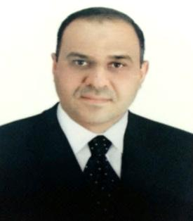

Name: Maitham Abas Makei
Bsc, Msc
Position : Assist. Lecturer in Microbiology
E-Mail:Maitham_abas@yahoo.com Mobile: +964 7803004142
List publications:
Isolation and Identification of bacterial genera and species that most sovereign in sawa lake water and determine their ability to withstand salinity in several levels of NaCl.(2012)
Study of some the pathogens isolated from the gums to the students of the Faculty of Science-AL-Muthanna University(2014).
Isolation and identification Listeria monocytogenes from Sleibiat waters river south western city of Samawha by using CHROMagar Listeria(2014).
The investigation of some bacteria contaminations paper currency circulation in the Iraqi domestic Market in the city of Samawah by using CHROM agar(2016).

