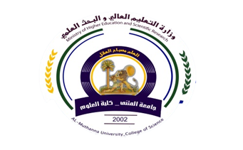
University: Al-Muthanna U.
College: Science
Department:Biology
Stage:frist
Lecturer name:Ashwaq Eyad Kadhim
Academic Status:.
Qualification: Master
Place of work: Biology

Republic of Iraq
The Ministry of Higher Education
& Scientific Research

49
Teaching plan for the semester form I
Course Instructor | Ashwaq Eyad Kadhim
E_mail | Ashwaq.alaakol@gmail.com
Title | Computer
Course Coordinator | First semester
Course Objective | Introduce students to deal with basic information of the computer and all the versions of the system
Course Description

Textbook
References
Course Assessment | Term Tests | Laboratory | Quizzes | Exams | Final Exam
 | 40% | 0% | 15% | 25% | 60%
General Notes

University: Al-Muthanna U.
College: Science
Department:Biology
Stage: Second
Lecturer name:Ashwaq Eyad Kadhim
Academic Status:.
Qualification: Master
Place of work: Biology

Republic of Iraq
The Ministry of Higher Education
& Scientific Research

49

Teaching plan for the semester form I
Week | Date | Topics Covered | Lab. Experiment Assignments | Notes
1 | 12/11 |  | Computer parts, Programs
2 | 16/11 |  | Laptop + quiz
3 | 23/11 |  | memories+ quiz
4 | 30/11 |  | The operating systems + quiz
5 | 7/12 |  | Windows system+ quiz
6 | 14/12 |  | Compering between the operating system+ quiz
7 | 21/12 |  | Icons , files and folders+ quiz
8 | 28/12 |  | The control panel
9 | 4/1 |  | Help and some of fames cases
10
11
12
13
14
15

Instructor Signature: Head of Dept. Signature:
Ashwaq Eyad Kadhim Asst. Prof. Dr Laith Abd Alhussn

